KS2 Home Learning Project
Week 1: Our Home Heroes
This week we will be completing activities around ‘Our Home Heroes’. This could be mums, dads, grandparents, sisters or anyone else who is looking after us right now. They are working so hard to keep you happy and safe. They are our Heroes!
Activity 1 | Activity 2
- Activity 1-Can you create a miniature town or city made from Lego that your home hero may live in?  Extension- Discuss a perfect looking city with your home hero. See if you can include any green areas, rivers, or ponds.  Note to parents: This geography activity is based on developing the ideas of what we might find in towns or cities. You could encourage your child to look at the photo below and recognise some common aspects of a city. They could then ask you what your perfect city might look like and try and create a miniature one using Lego.  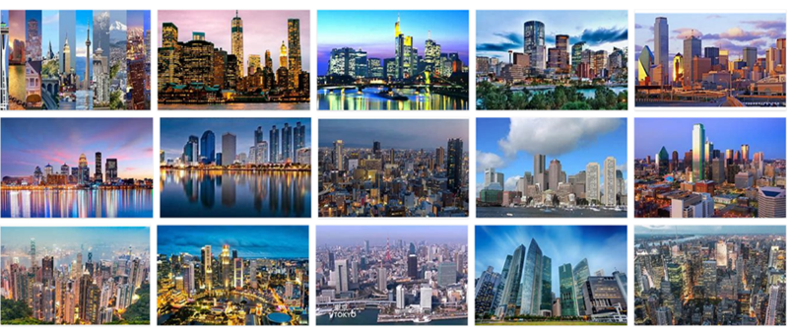 | Activity 2- Create or copy the template of the weather diary. From Monday to Friday, try to monitor the weather in the Morning, Afternoon and in the Evening. Talk to your home hero and discuss the weather. What is their favourite weather and why?  Extension: Can you write a paragraph about this week’s weather and if you and your home hero has enjoyed it? Think about activities you do with your home hero in different types of weather.  Note to parents: This geography activity is about getting the child outside to experience the weather and to identify the different types of weather. Students may find it easier if the monitoring times are more precise so they can get into a routine of when they are needing to monitor the weather each day. This also allows students to ask you about your perfect weather and whether you enjoyed the day or not.
Activity 3
Can you Create a Passport for your Home Hero? Design a pocket-sized passport for your home hero. Try to include name, place of birth, date of birth, date issued and interests and then a signature to finish. Also try to draw a picture of the areas you have visited with your home hero.

Extension: Ask your home hero, out of all the places they have visited which one has been their favourite and why?
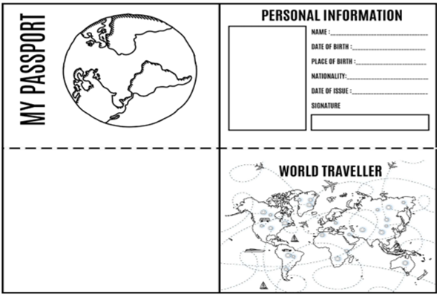

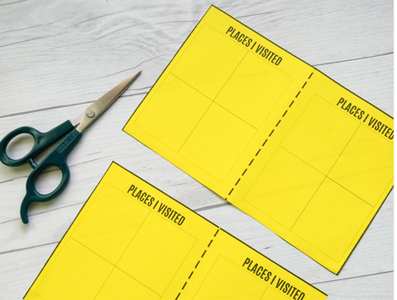

For a printable passport please follow the link https://www.makeandtakes.com/wp-content/uploads/Mini-Passport-Book-Template.pdf

Note to parents: This geography task is based on creating a miniature identity for their home hero through a passport. This will encourage students to ask questions and discuss places you have visited.

