KS2 Home Learning Project
Week 1: Our Home Heroes
This week we will be completing activities around ‘Our Home Heroes’. This could be mums, dads, grandparents, sisters or anyone else who is looking after us right now. They are working so hard to keep you happy and safe. They are our Heroes!
Activity 1 | Activity 2
Look at photographs of you and your home hero together throughout your life. Can you ask questions like ‘who’ ‘where’ and ‘when’ as you are looking at them?  Extension – Ask your home hero when the pictures were taken. Build a timeline of special events that have taken place during the time you have spent with your home hero. Think about including days out, holidays, family birthdays and the birth of brothers, sisters or cousins.  Note to parents: This is a history based activity based on developing the concept of history and the passage of time. You could encourage the children to ask you questions about where the photograph was taken or who is in the image. To extend the activity, you could support the children in ordering the pictures in chronological order. | Create a special Superhero card to thank our home heroes. Create your cards and write a special note inside for your chosen hero  Use the Superhero card activity sheet for step-by-step instructions on how to create the cards.  Alternatively, you can follow this link for a video tutorial for guidance;  https://www.thebestideasforkids.com/super-hero-craft/  Note to parents: This is an Art based activity is to practice drawing, cutting and fine motor skills. Please encourage the pupils to collect their own equipment where possible.  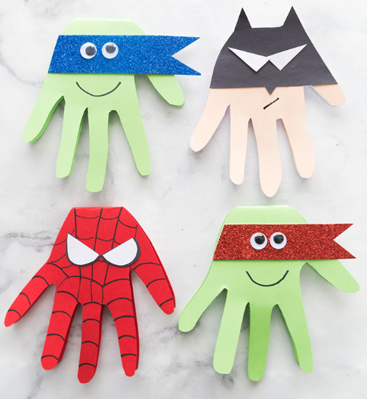
Activity 3 | Activity 4
Write an acrostic poem about your hero at home. Try to be as adventurous as you can with the vocabulary you use to describe your hero.  Note to parents: This is an english activity to develop writing skills. To help your child, write a list of words you could use to describe their hero.  You could send your childs poem to their class teacher to publish in our newsletter. | Draw a picture of your home hero. Write a few words to describe their qualities. For example, kind, caring and considerate.  Note to parents: This is a RE based activity based on developing the concept of taking time to think and consider other peoples qualities. A home hero can be anyone who has been helping to look after others whilst the students are at home. You could encourage your child to discuss their ideas out loud or to reflect quietly on how their home hero has supported them. To extend the activity, you could support your child in reflecting on more than one home hero or writing a sentence about the qualities of their home hero.

