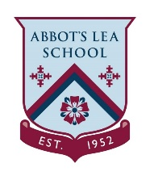
Key Stage 2 Home Learning
My Family Superhero

This week we will be completing activities around ‘Our Home Heroes’. This could be mums, dads, grandparents, sisters or anyone else who is looking after us right now. They are working so hard to keep you happy and safe. They are our Heroes!

