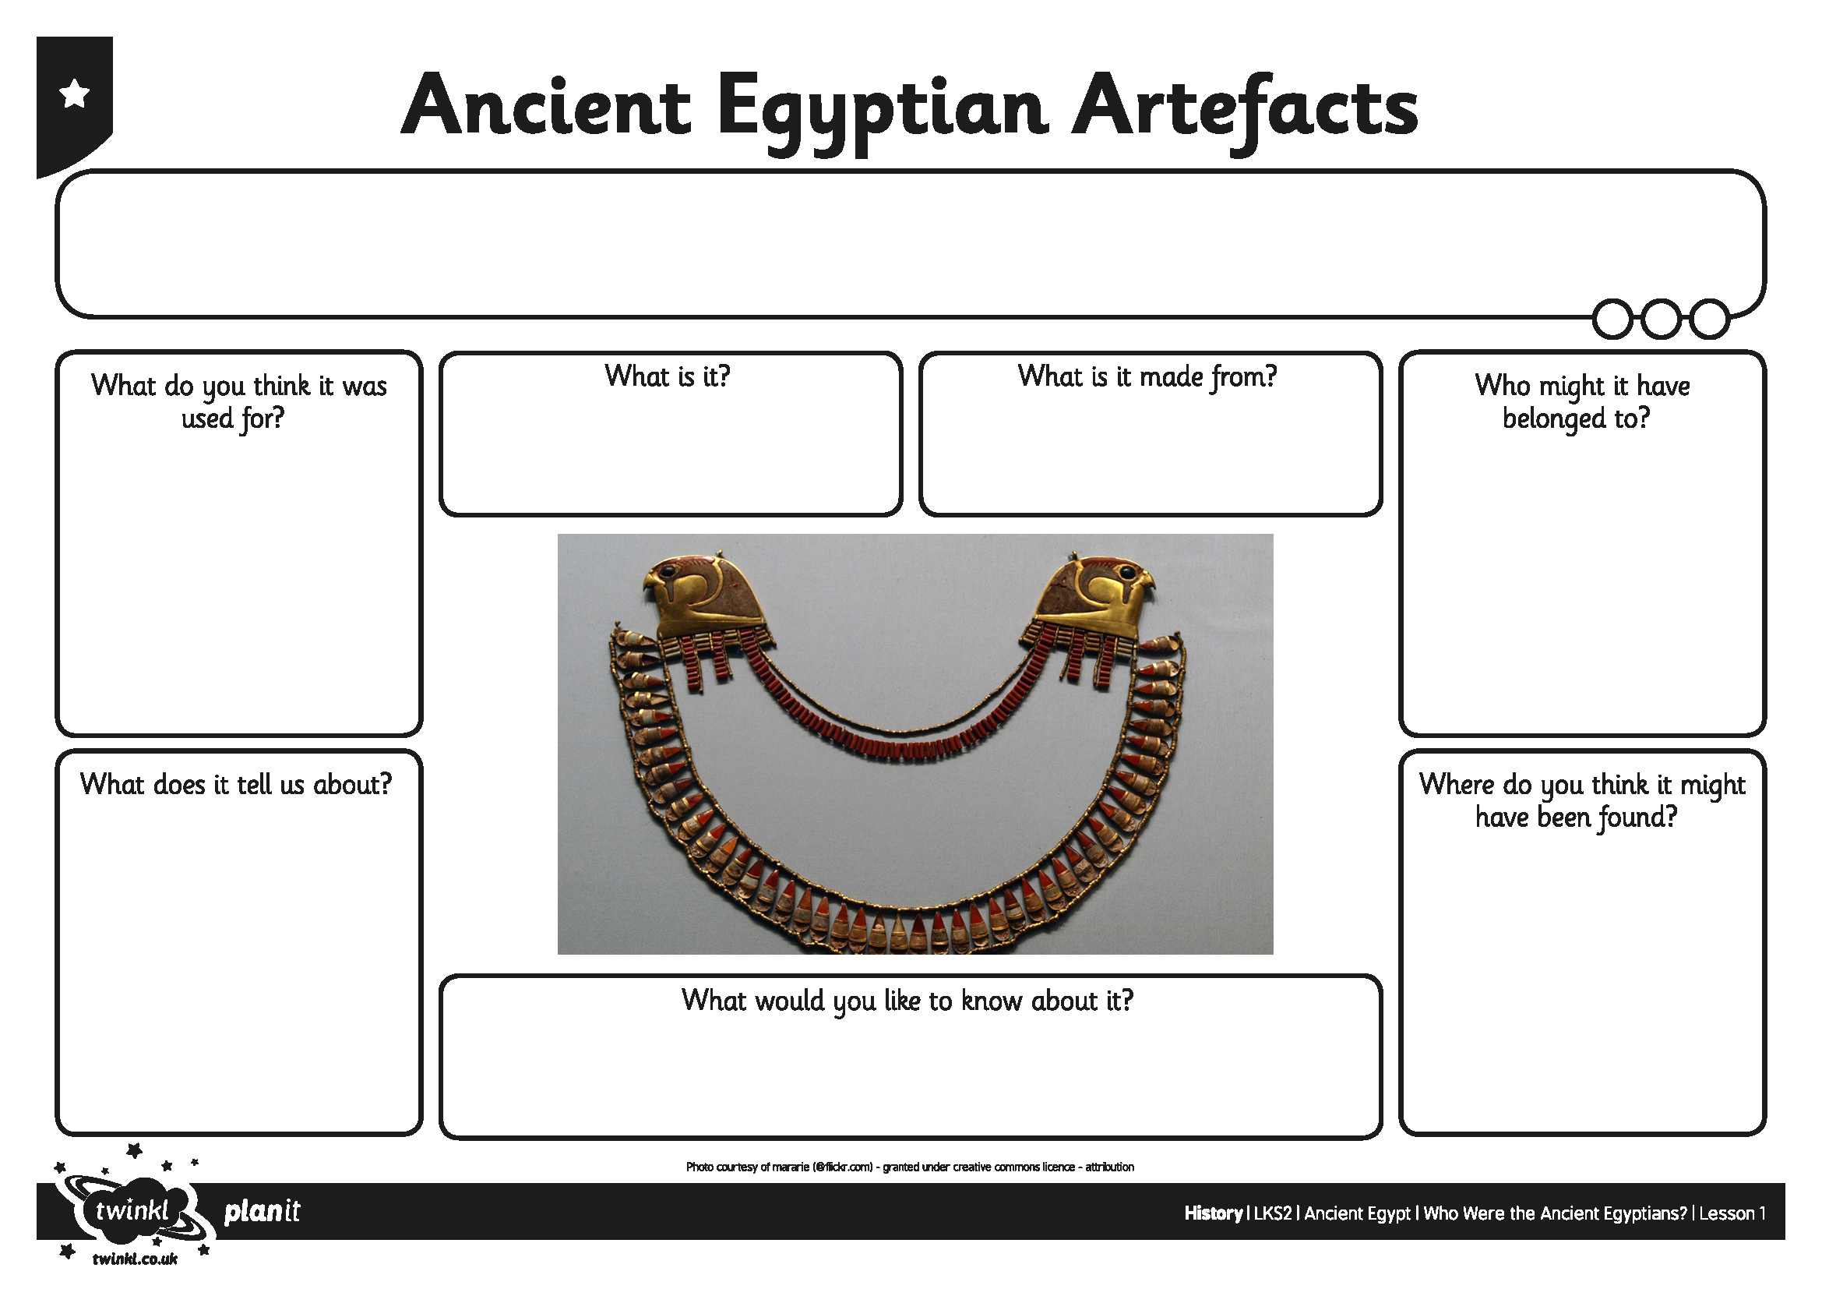
I can find out about ancient Egyptian life by looking at artefacts.
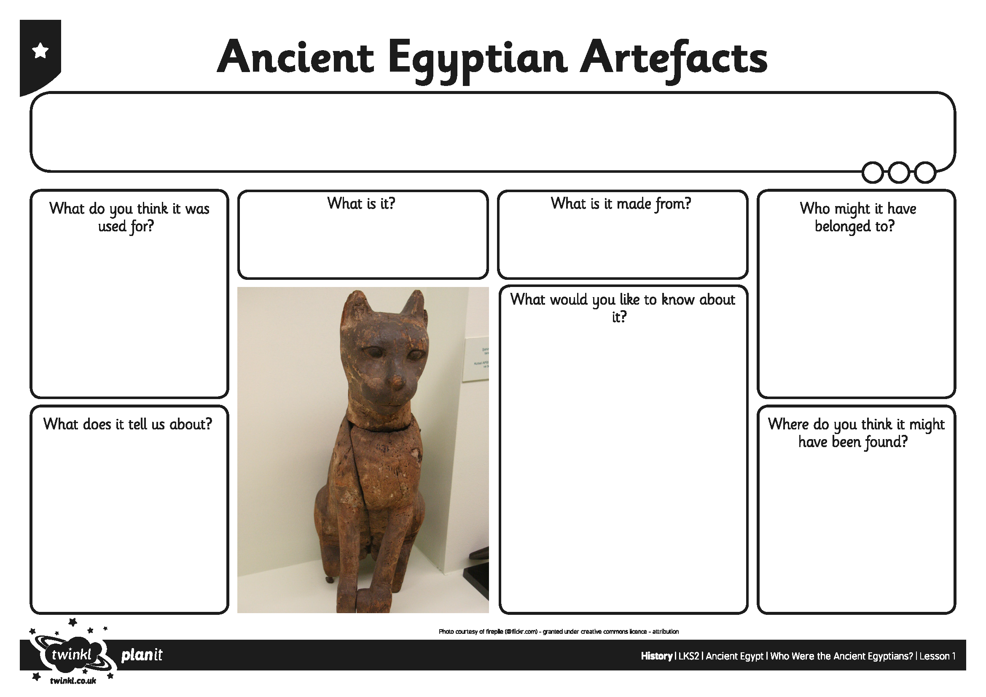
I can find out about ancient Egyptian life by looking at artefacts.
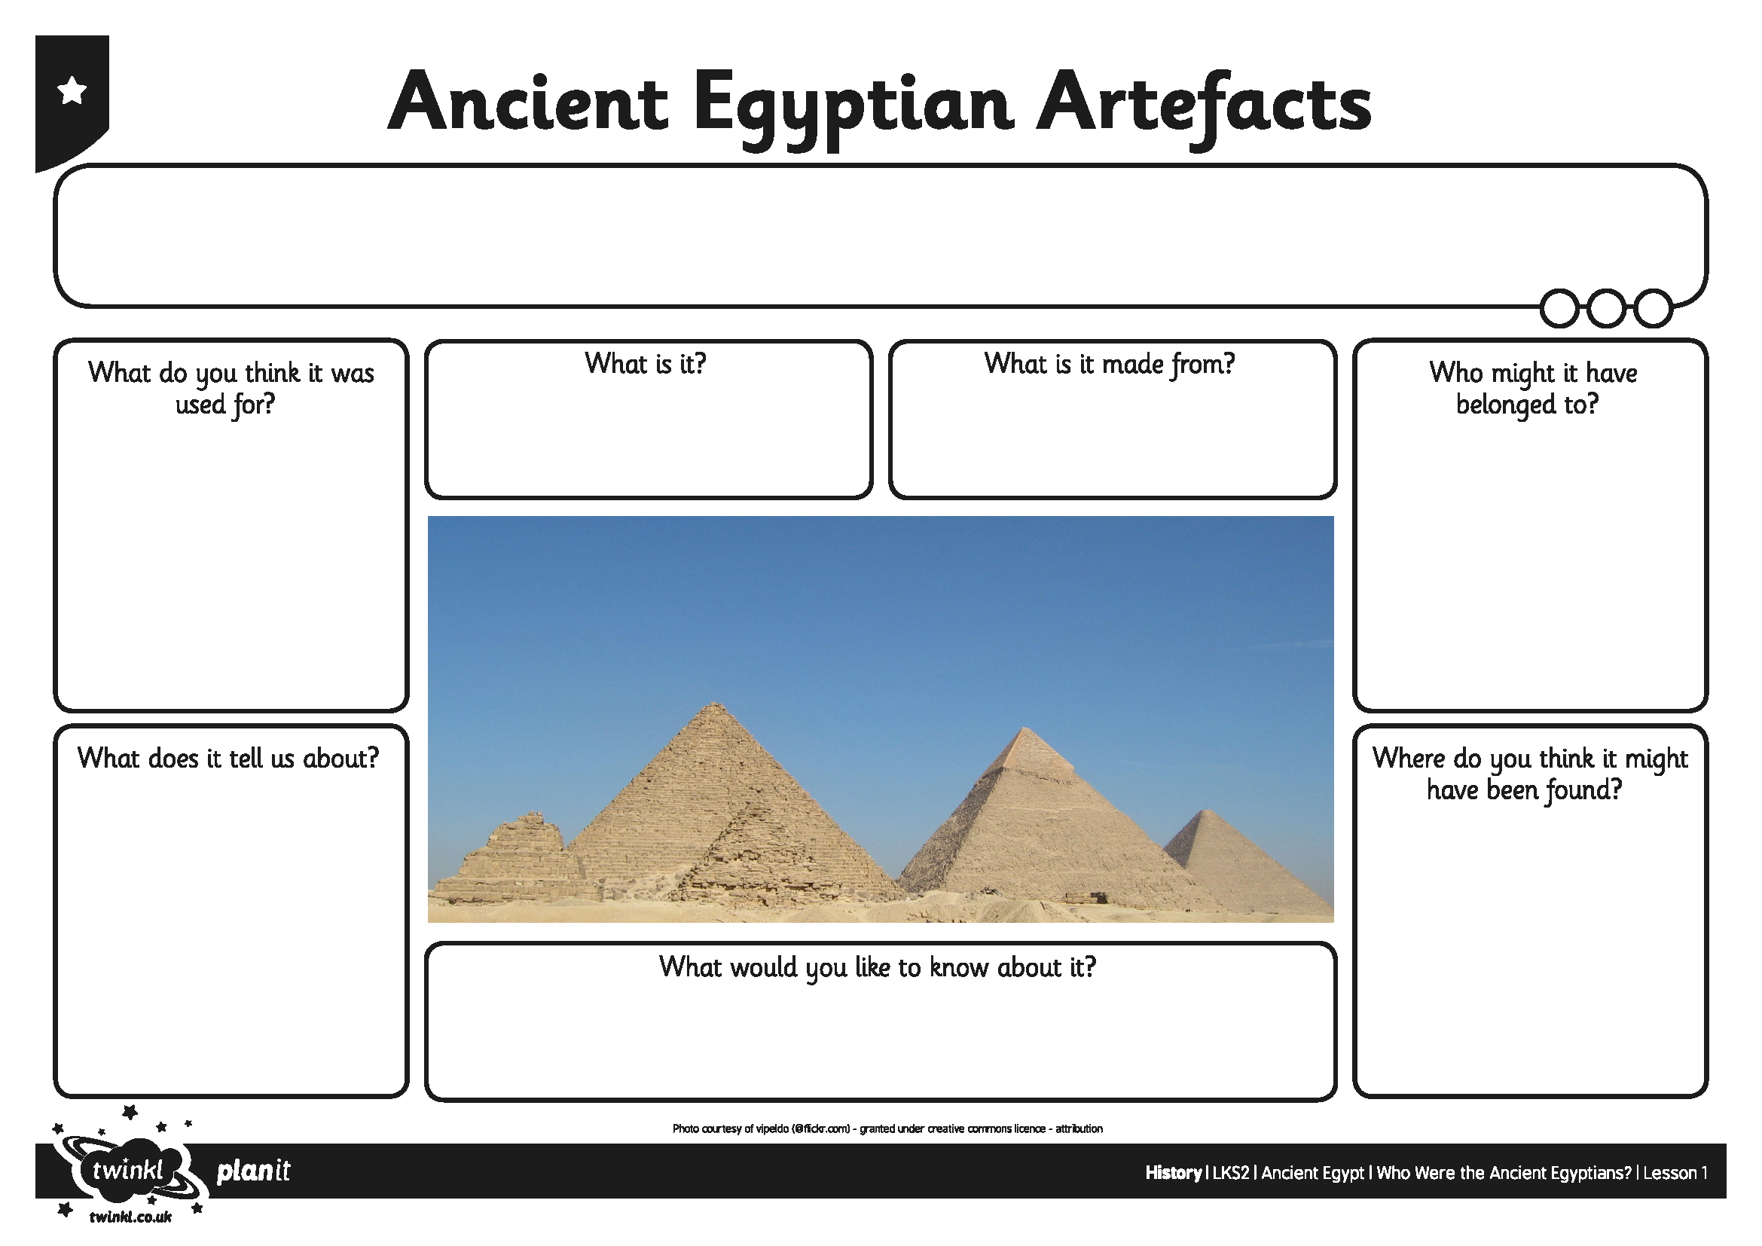
I can find out about ancient Egyptian life by looking at artefacts.
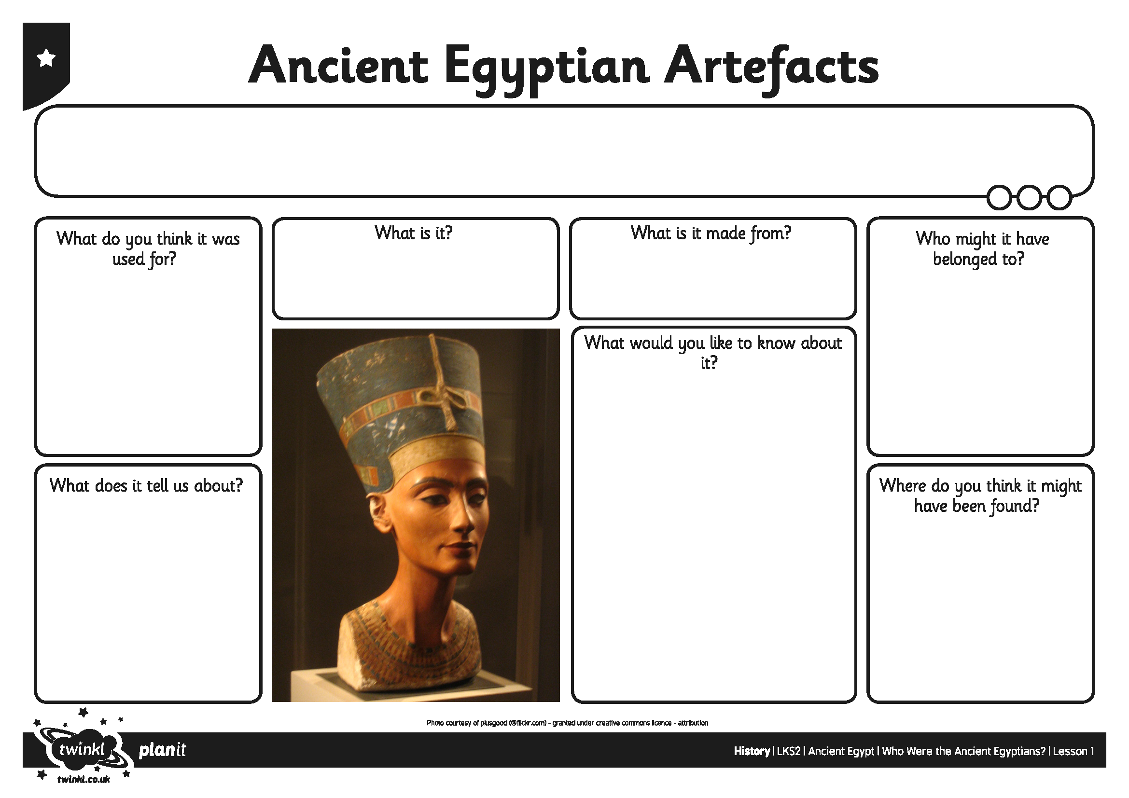
I can find out about ancient Egyptian life by looking at artefacts.
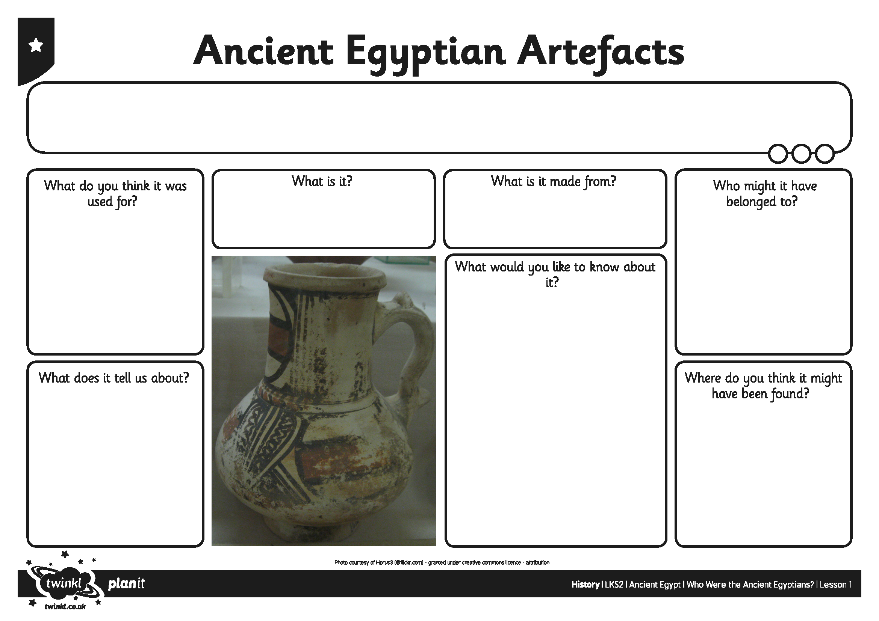
I can find out about ancient Egyptian life by looking at artefacts.
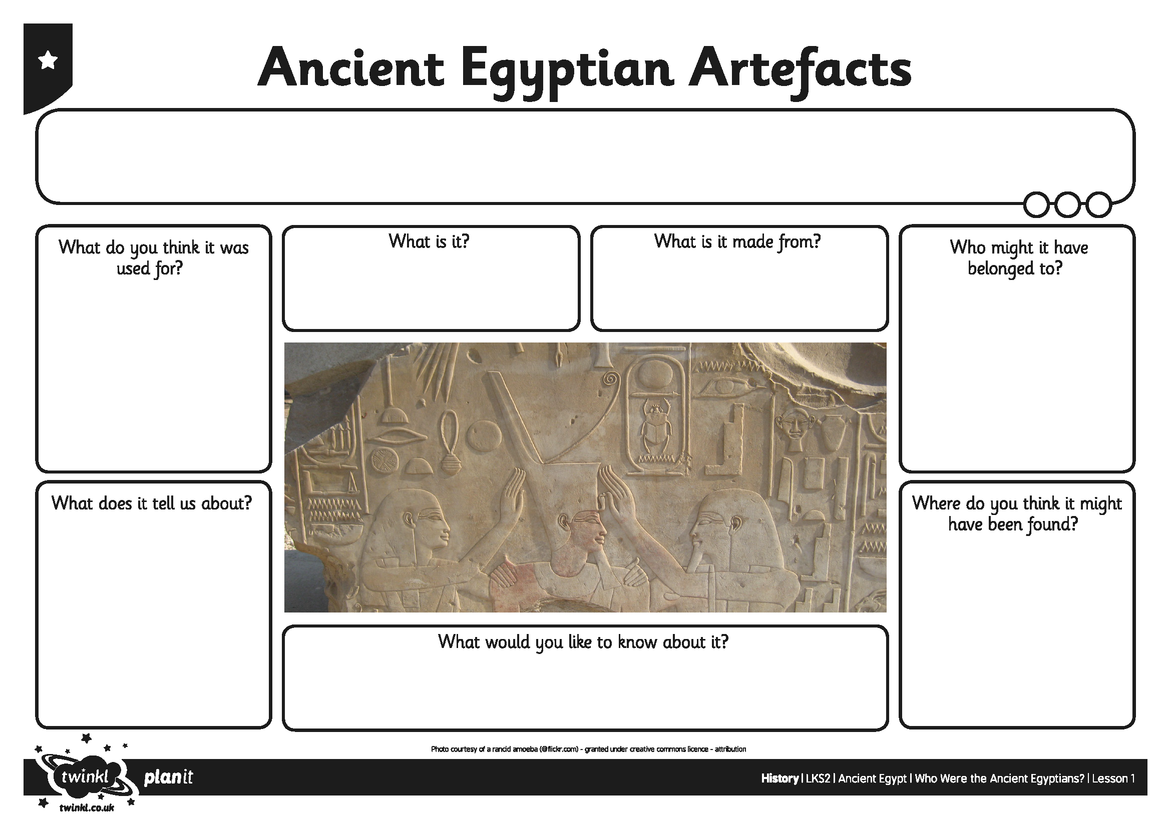
I can find out about ancient Egyptian life by looking at artefacts.
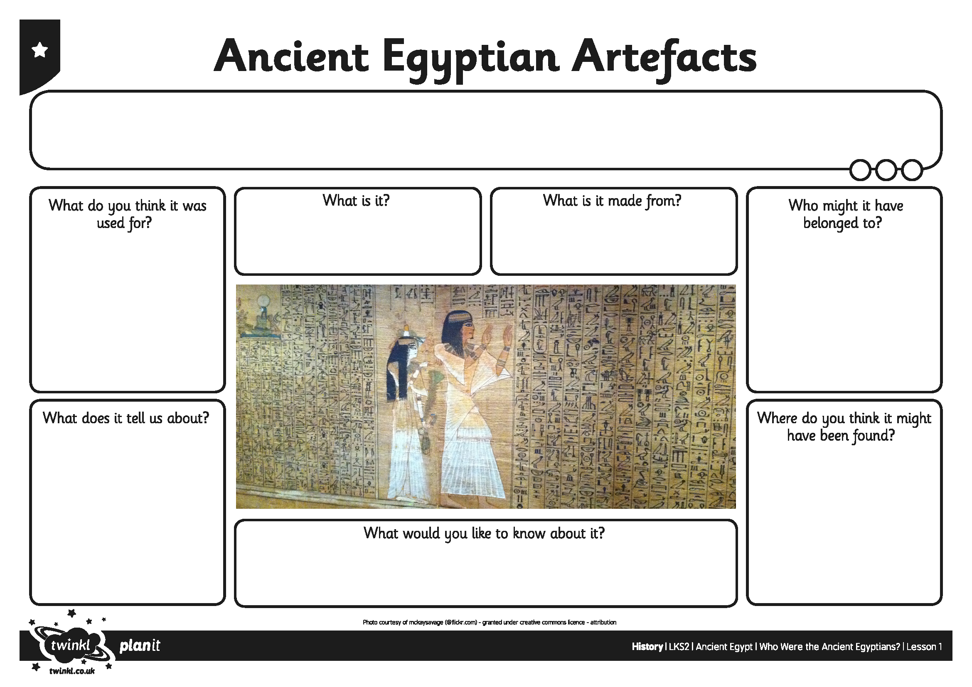
I can find out about ancient Egyptian life by looking at artefacts.
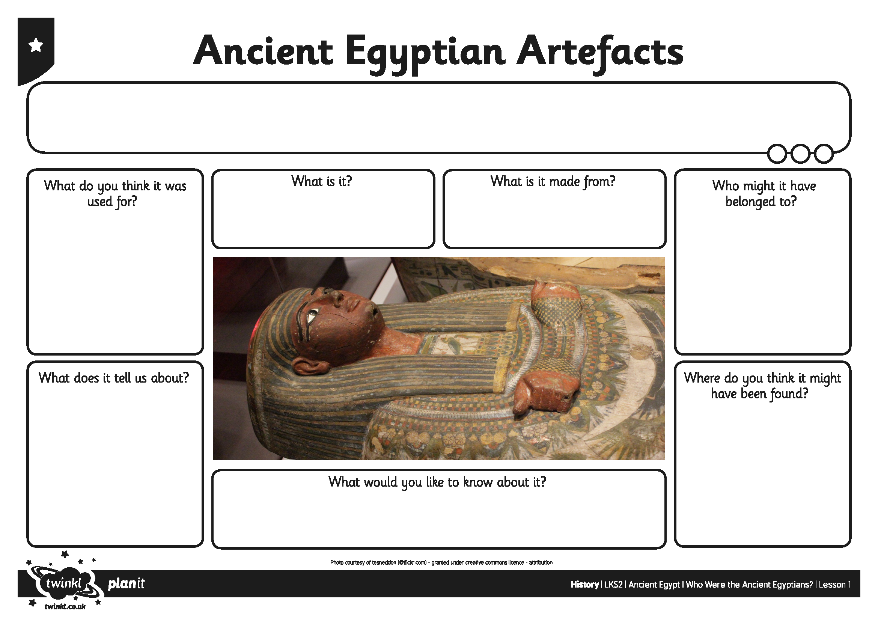
I can find out about ancient Egyptian life by looking at artefacts.
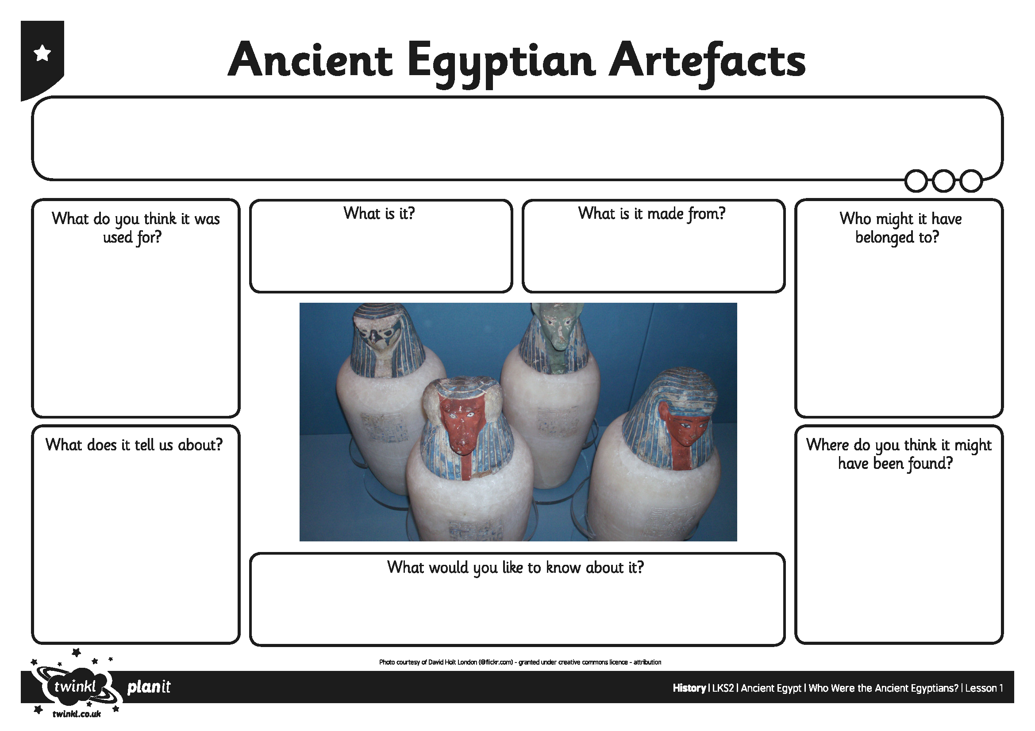
I can find out about ancient Egyptian life by looking at artefacts.
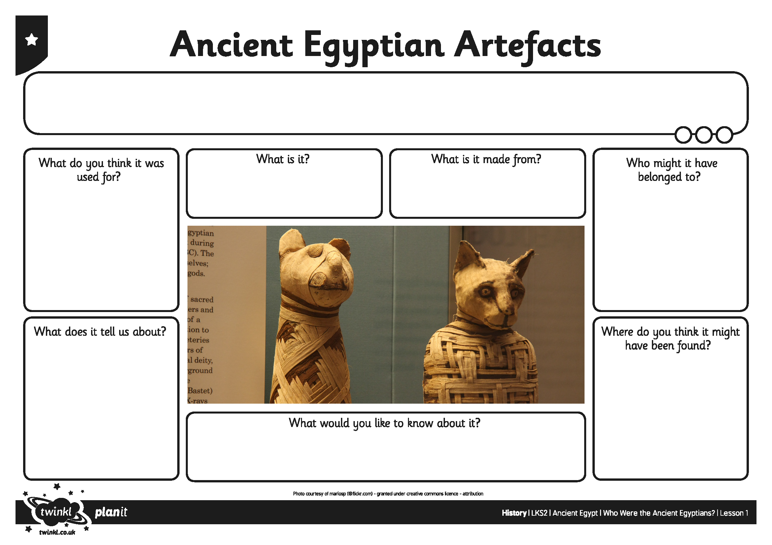
I can find out about ancient Egyptian life by looking at artefacts.
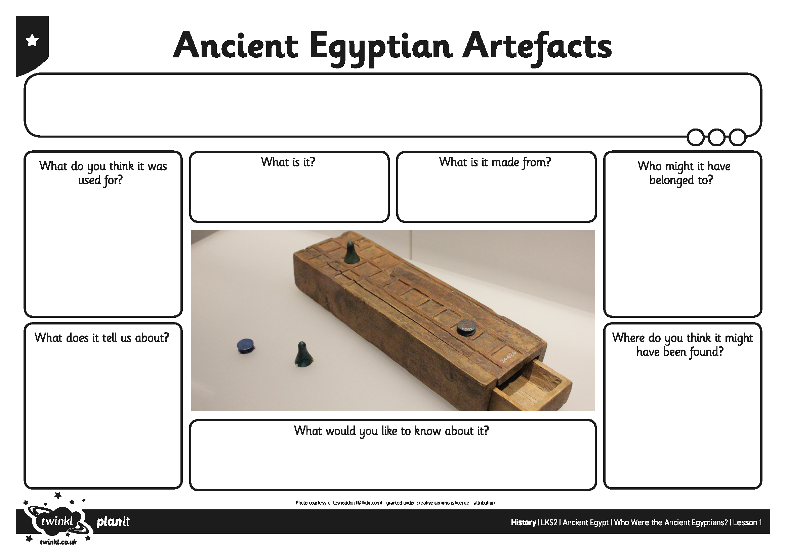
I can find out about ancient Egyptian life by looking at artefacts.
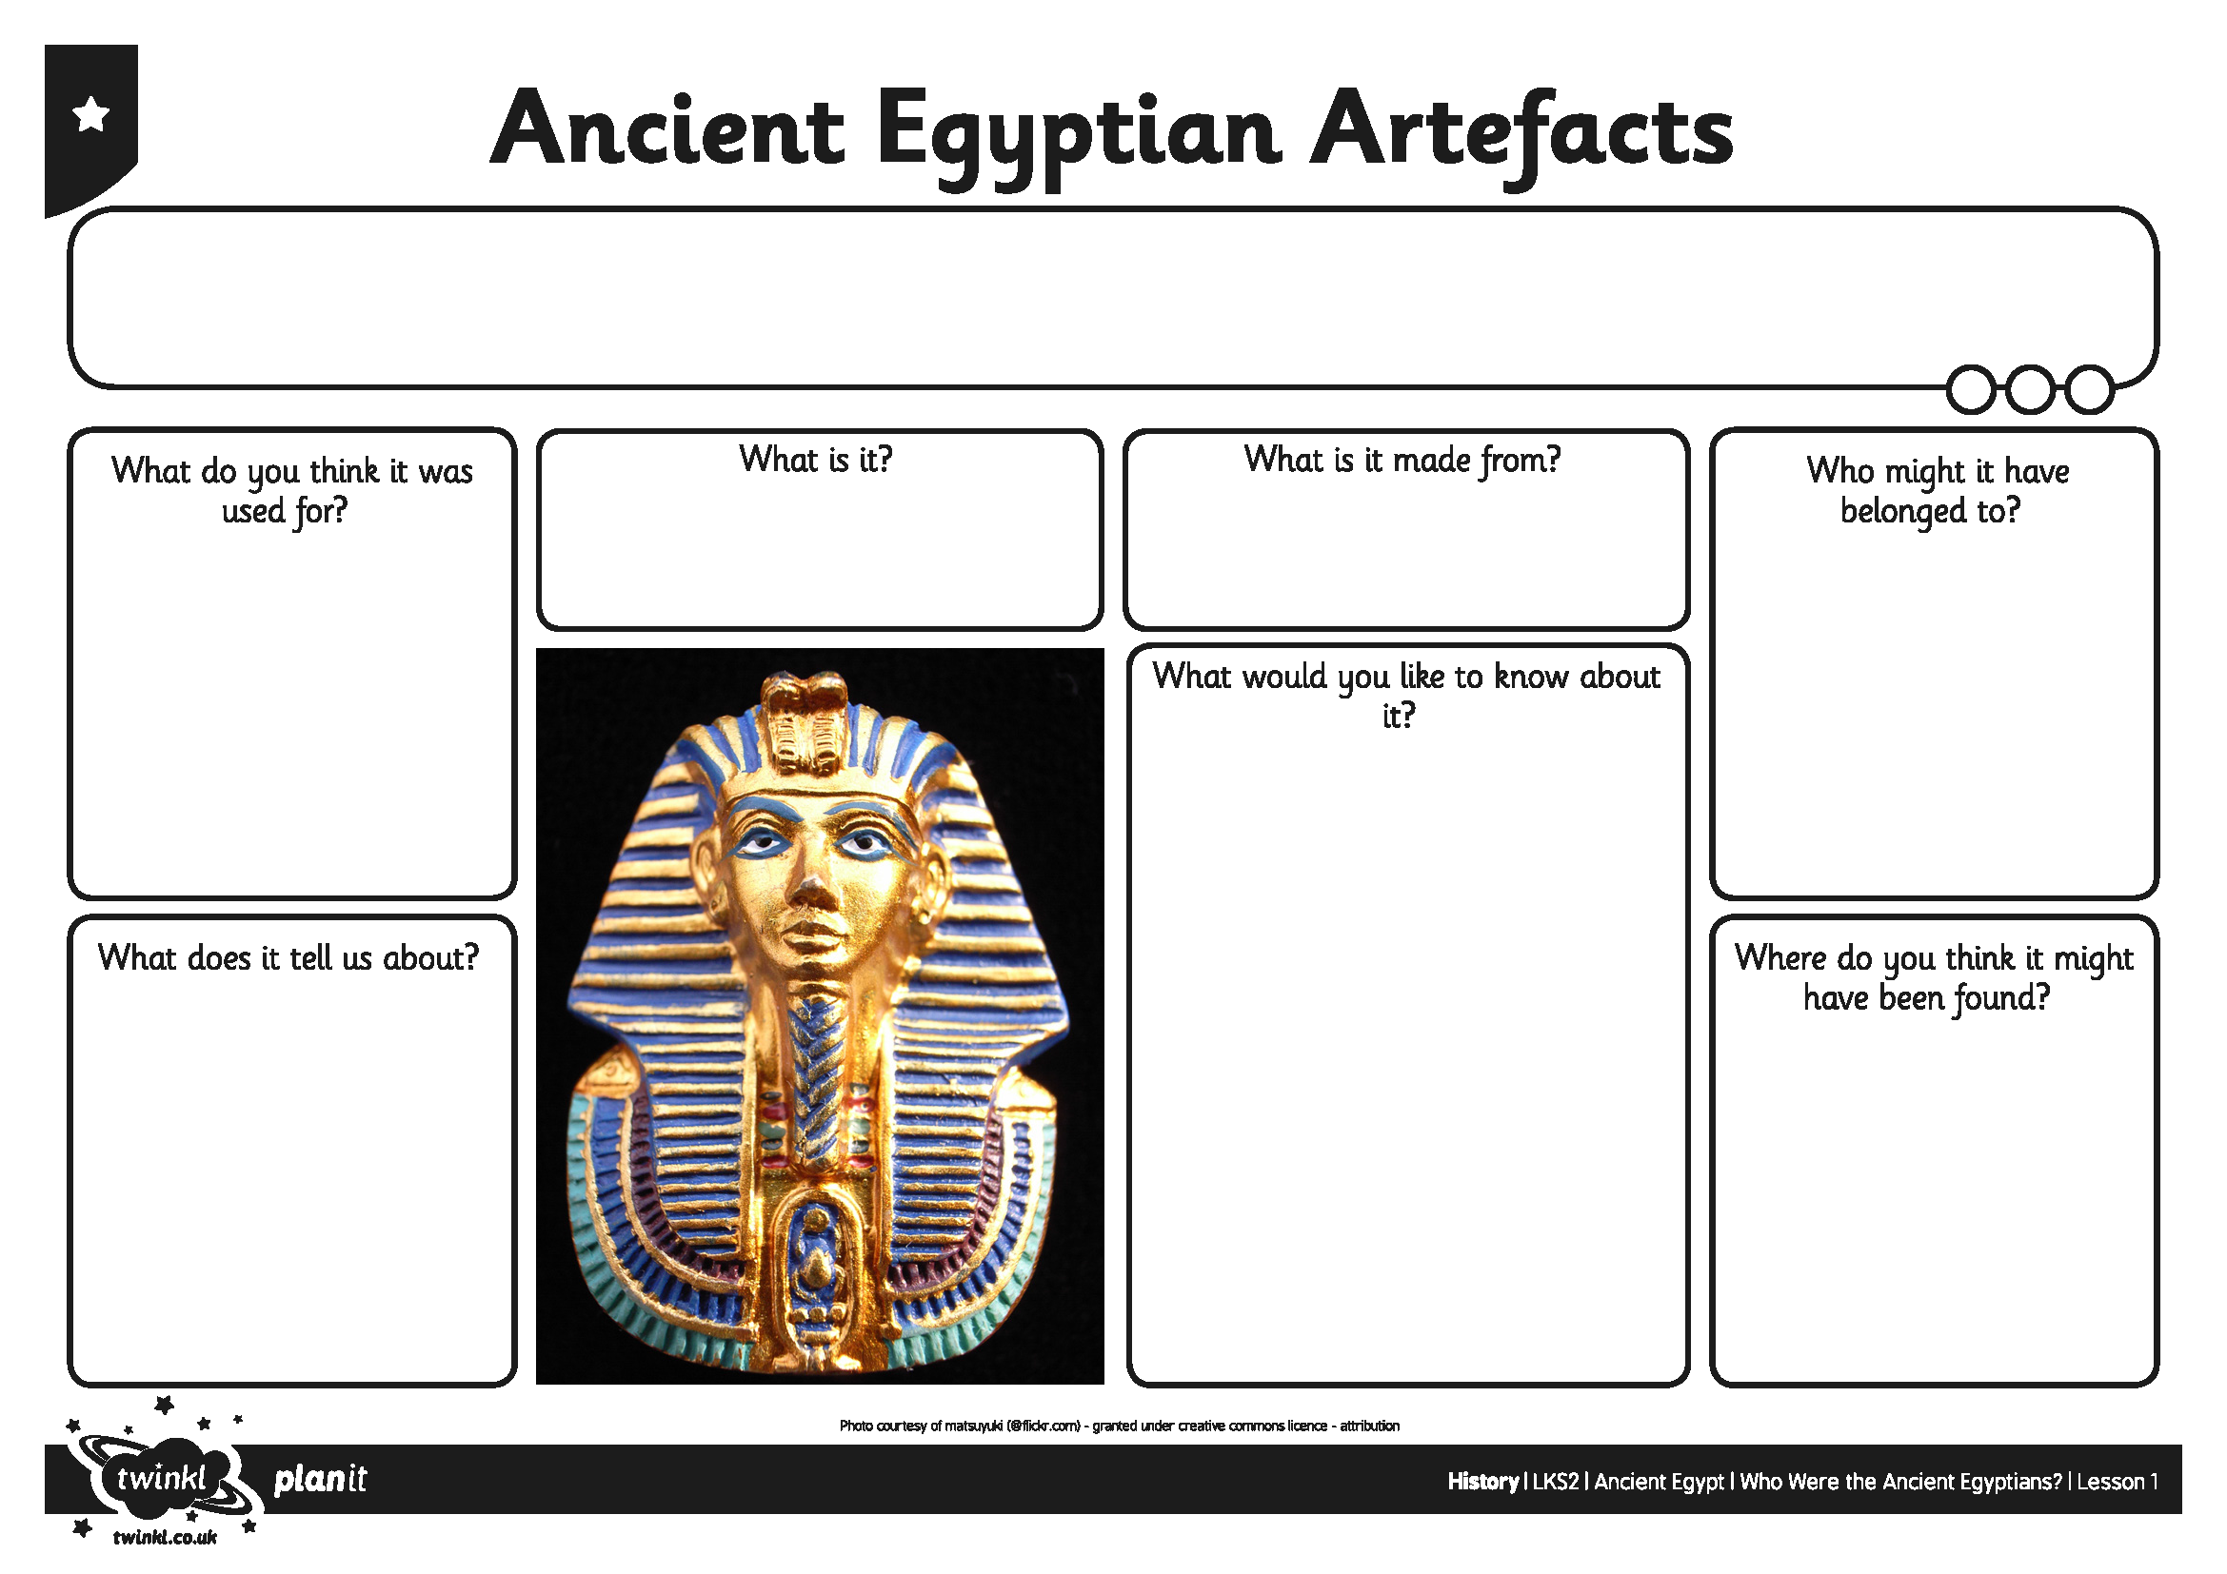
I can find out about ancient Egyptian life by looking at artefacts.
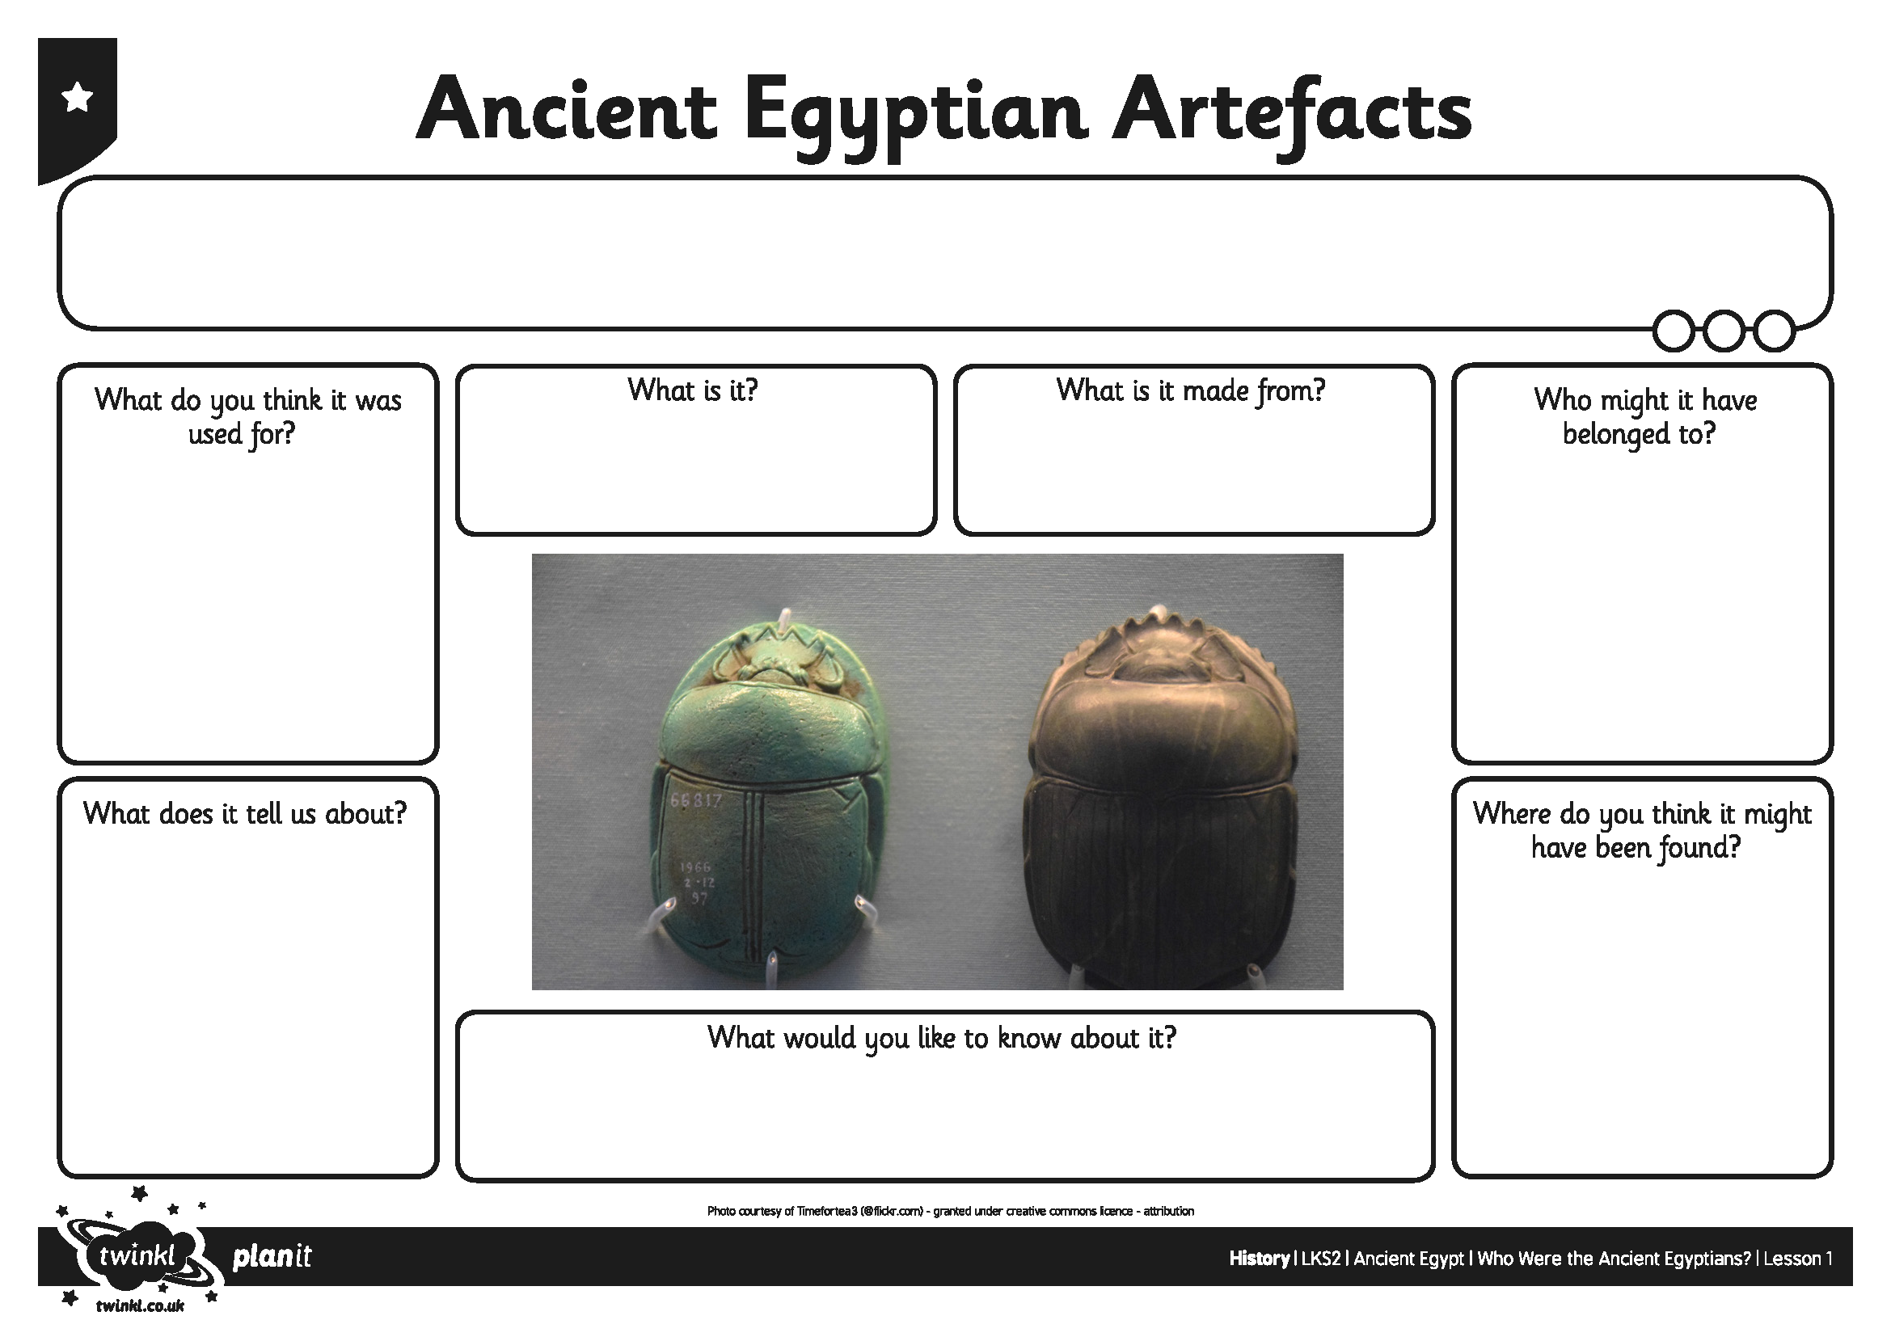
I can find out about ancient Egyptian life by looking at artefacts.

