**Laundry Check List**

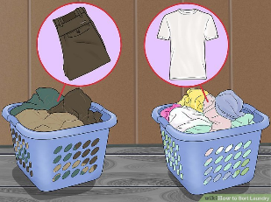

staff comment and date/day

Tick

1. Separate colours from lights/whites

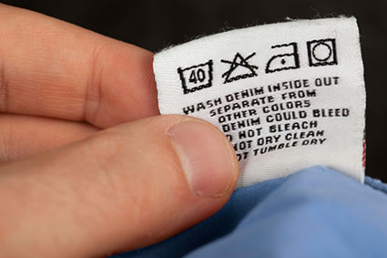

1. Check the temperature instructions

on the garments.



1. Add washing detergent to machine



1. Put the laundry in the washing machine

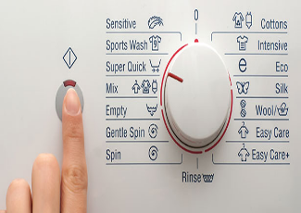

1. Choose the correct settings and

press start.

Parent/carer comment and date/day

Tick



1. When the wash has finished

remove clean, damp laundry

from the machine.

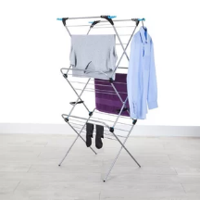

1. Hang laundry up to dry

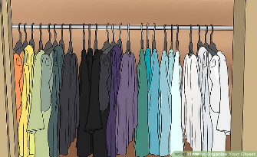

1. When dry, fold/hang up clothes

and put away.