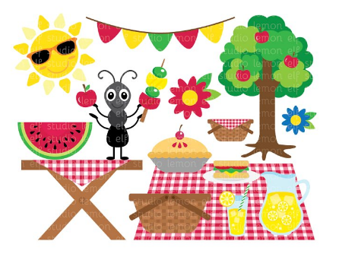
Let’s Have a Picnic!

This terms theme is “Outdoors”. Keeping that in mind why not invite the family (who you live with) to a picnic. If you have a garden/yard or balcony, set up the picnic outside. If not, set up a picnic area in your living room. You can use blankets and cushions for either.
Make or print your own invites.
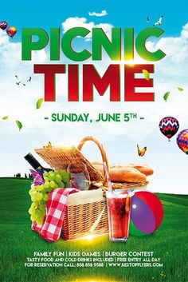
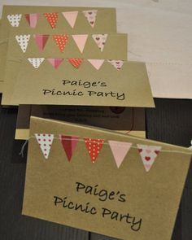

Design a menu.

Copy and paste the link below for some great picnic food ideas.
https://www.bbcgoodfood.com/recipes/collection/picnic-recipes-kids

