Macbeth
There have been many adaptations of Macbeth throughout the years. One of the most popular is the version created in 2015. Here the director made the film almost as if it is a horror film.
Imagine you are going to direct your own version of Macbeth
What actors would you have playing the characters?
What time would you set it in?
What setting would you give it?
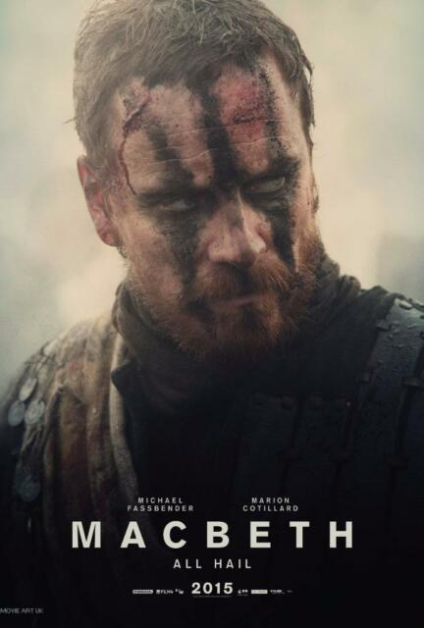
Design a poster or a Powerpoint presenting your version of the film.
Remember to state what actors will be staring and name yourself as the director!
Give your film a slogan.

