Make your own boat
What you will need:
- scrub sponges
- straws
- Card or paper
- scissors

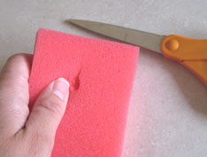
What to do:
- Using your scissors, carefully cut a small slit at the top of your sponge.

- Then, cut a triangle shape for a sail out of your card or paper.
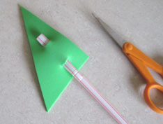
- Next, cut two slits into the triangle so that the straw can be hooked, one at the top and one at the bottom.

- Now, place the straw with the triangle sail on, into the slit of the sponge.

- Put your sponge boat into a bath or bucket of water and watch it float - you could make more and have a boat race.

- Have fun!!!
