Making a bacon sandwich
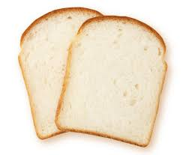

Take two slices of bread

Spread butter on one side of each piece

Take three (3) rashers of bacon.

Put a tablespoon of oil in a frying pan.

Cook bacon in a frying pan, turning it occasionally, until it is crispy, about 5 minutes.
When cooked place bacon on plate lined with paper towel to remove excess oil.

Put bacon between two slices of bread to make a sandwich.

Add tomato ketchup or brown sauce to taste.

