Marble Run Painting
You will need:
- Cardboard box lid or old tray
- Paint
- Paper
- Marbles

What to do:
- First put your paper into your cardboard lid or tray - you might need to cut your paper to size.
- Then, squeeze your paint straight from the bottle, onto the paper in the tray - use lots of different colours.
- Next, take a couple of marbles and place them on the tray.
- Finally, all you have to do now is gently rock the tray from side to side so the marbles will roll through the paint and create a picture.
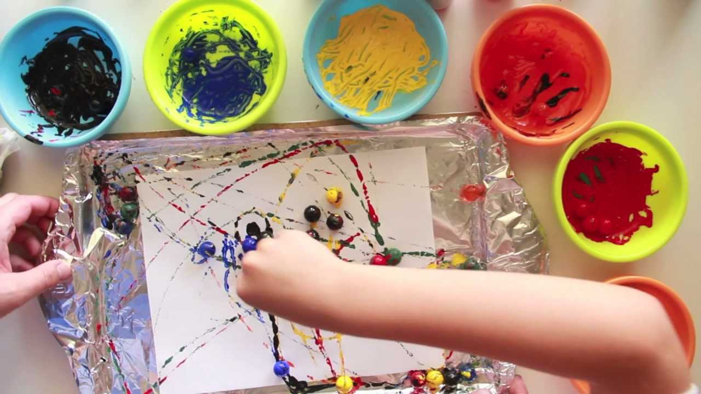
- Have fun!!!

Video Demonstration: https://www.youtube.com/watch?v=smx540T5mD4

