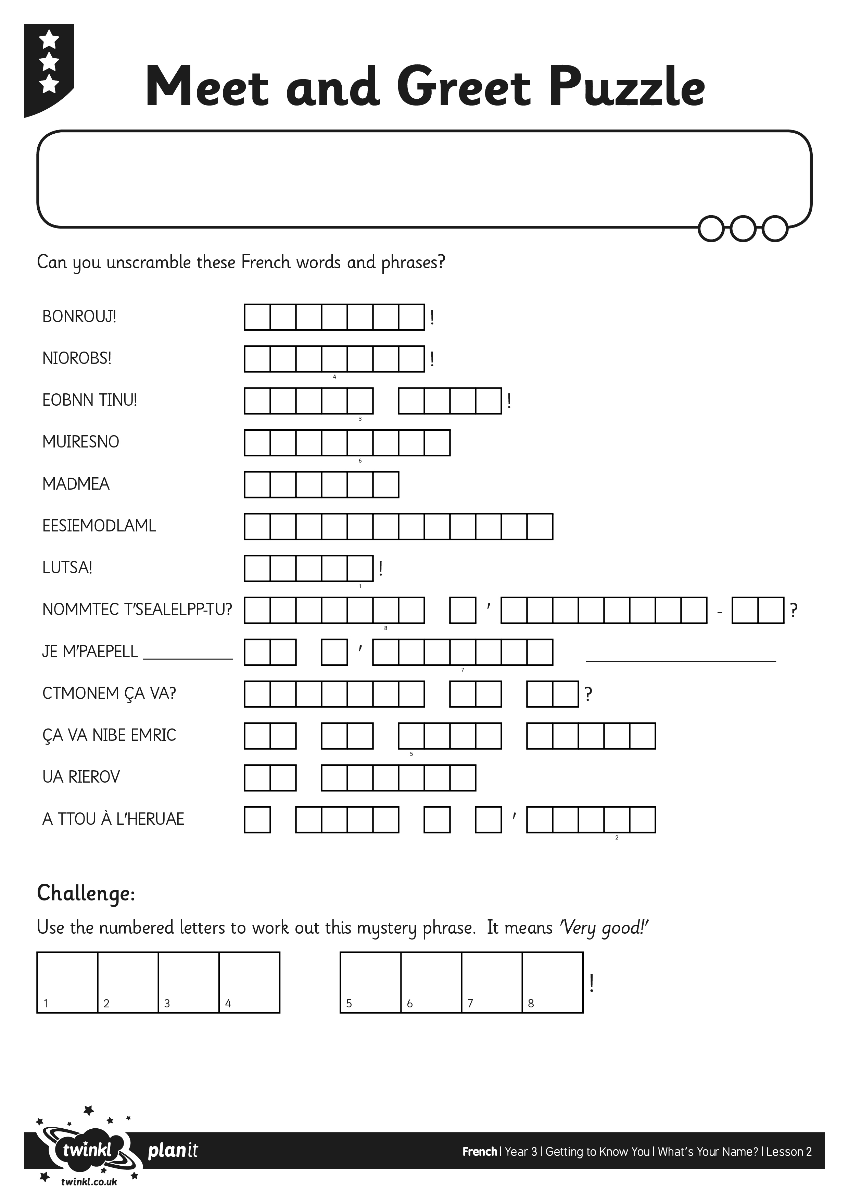
I can give my name in French.
I can ask someone’s name in French.

