Moose Head – Hand Print Craft:
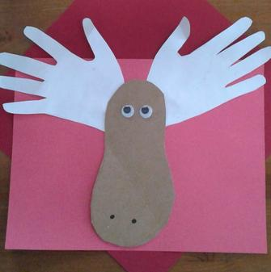
Materials:
Brown paper/white card, googly eyes, white glue, marker, glue stick.

Step 1 Cut out large peanut shape using brown paper.
Step 2 Trace child’s hand. Cut them out.
Step 3 Have your children piece them together and glue to brown paper to form the moose!
Step 4 Glue the googly eyes using white glue.
Step 5 Draw two nostrils with the marker.
Step 6 Let dry then display or glue into scrapbook.

