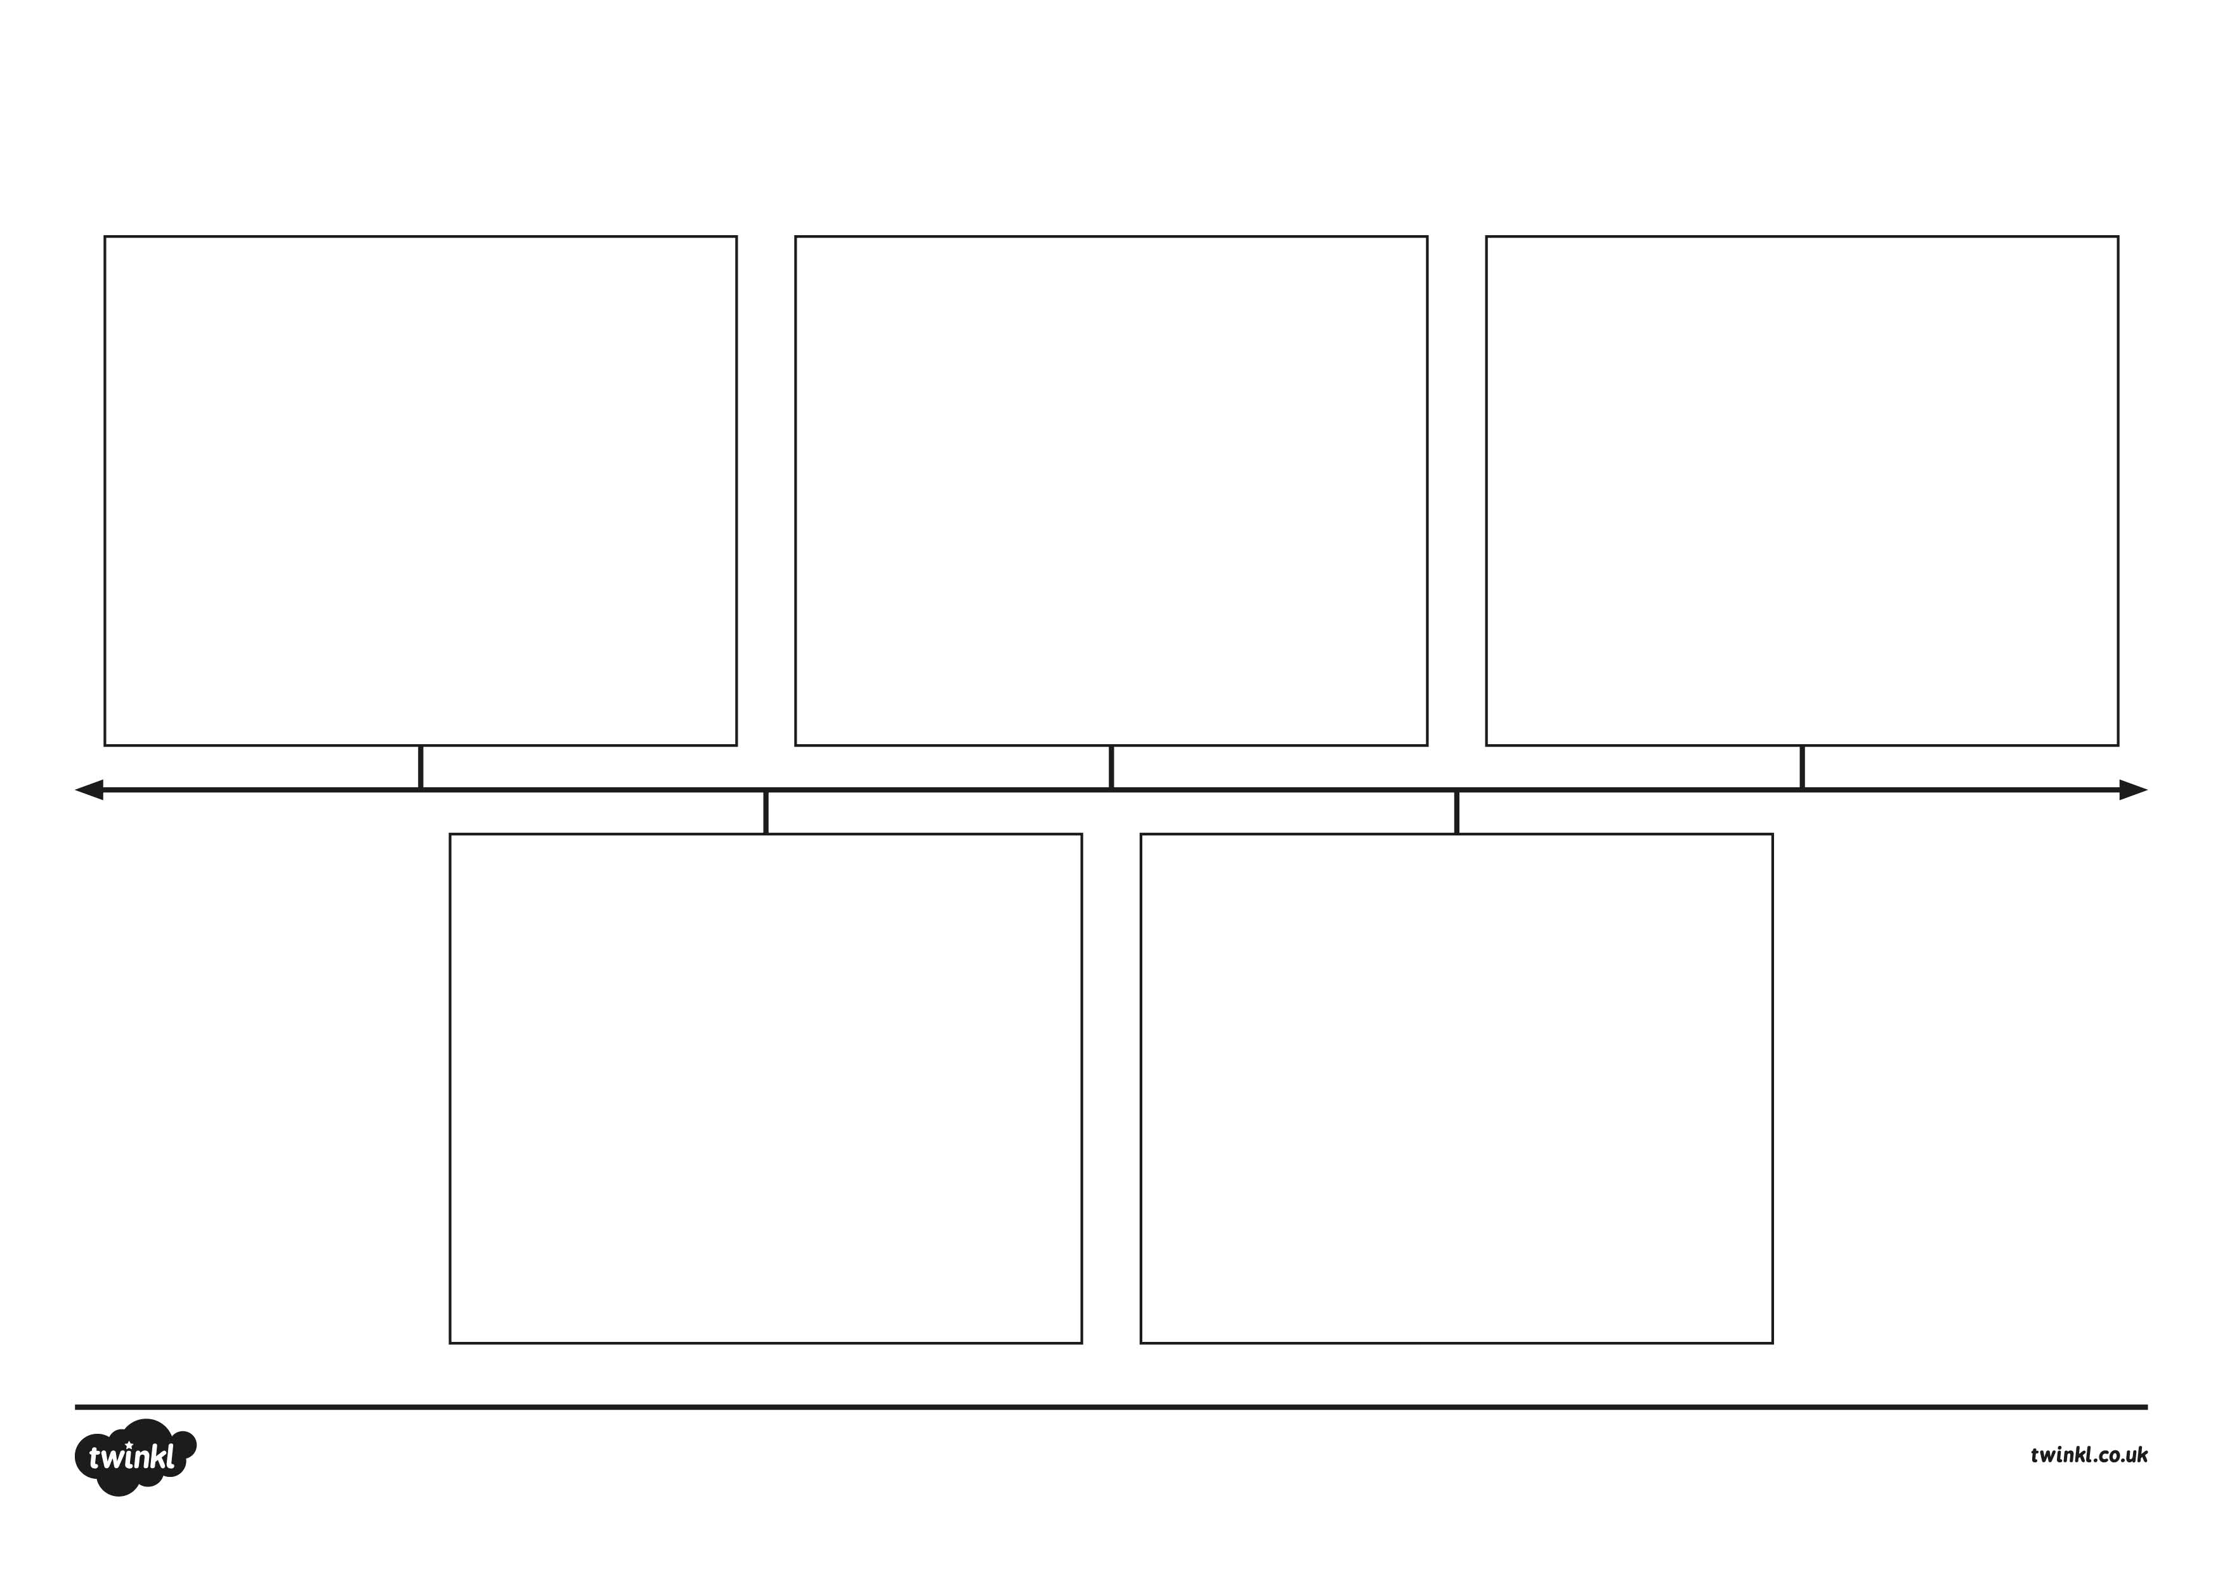
Event:
Date:
Event:
Date:
Event:
Date:
Event:
Date:
Event:
Date:
Neil Armstrong Timeline
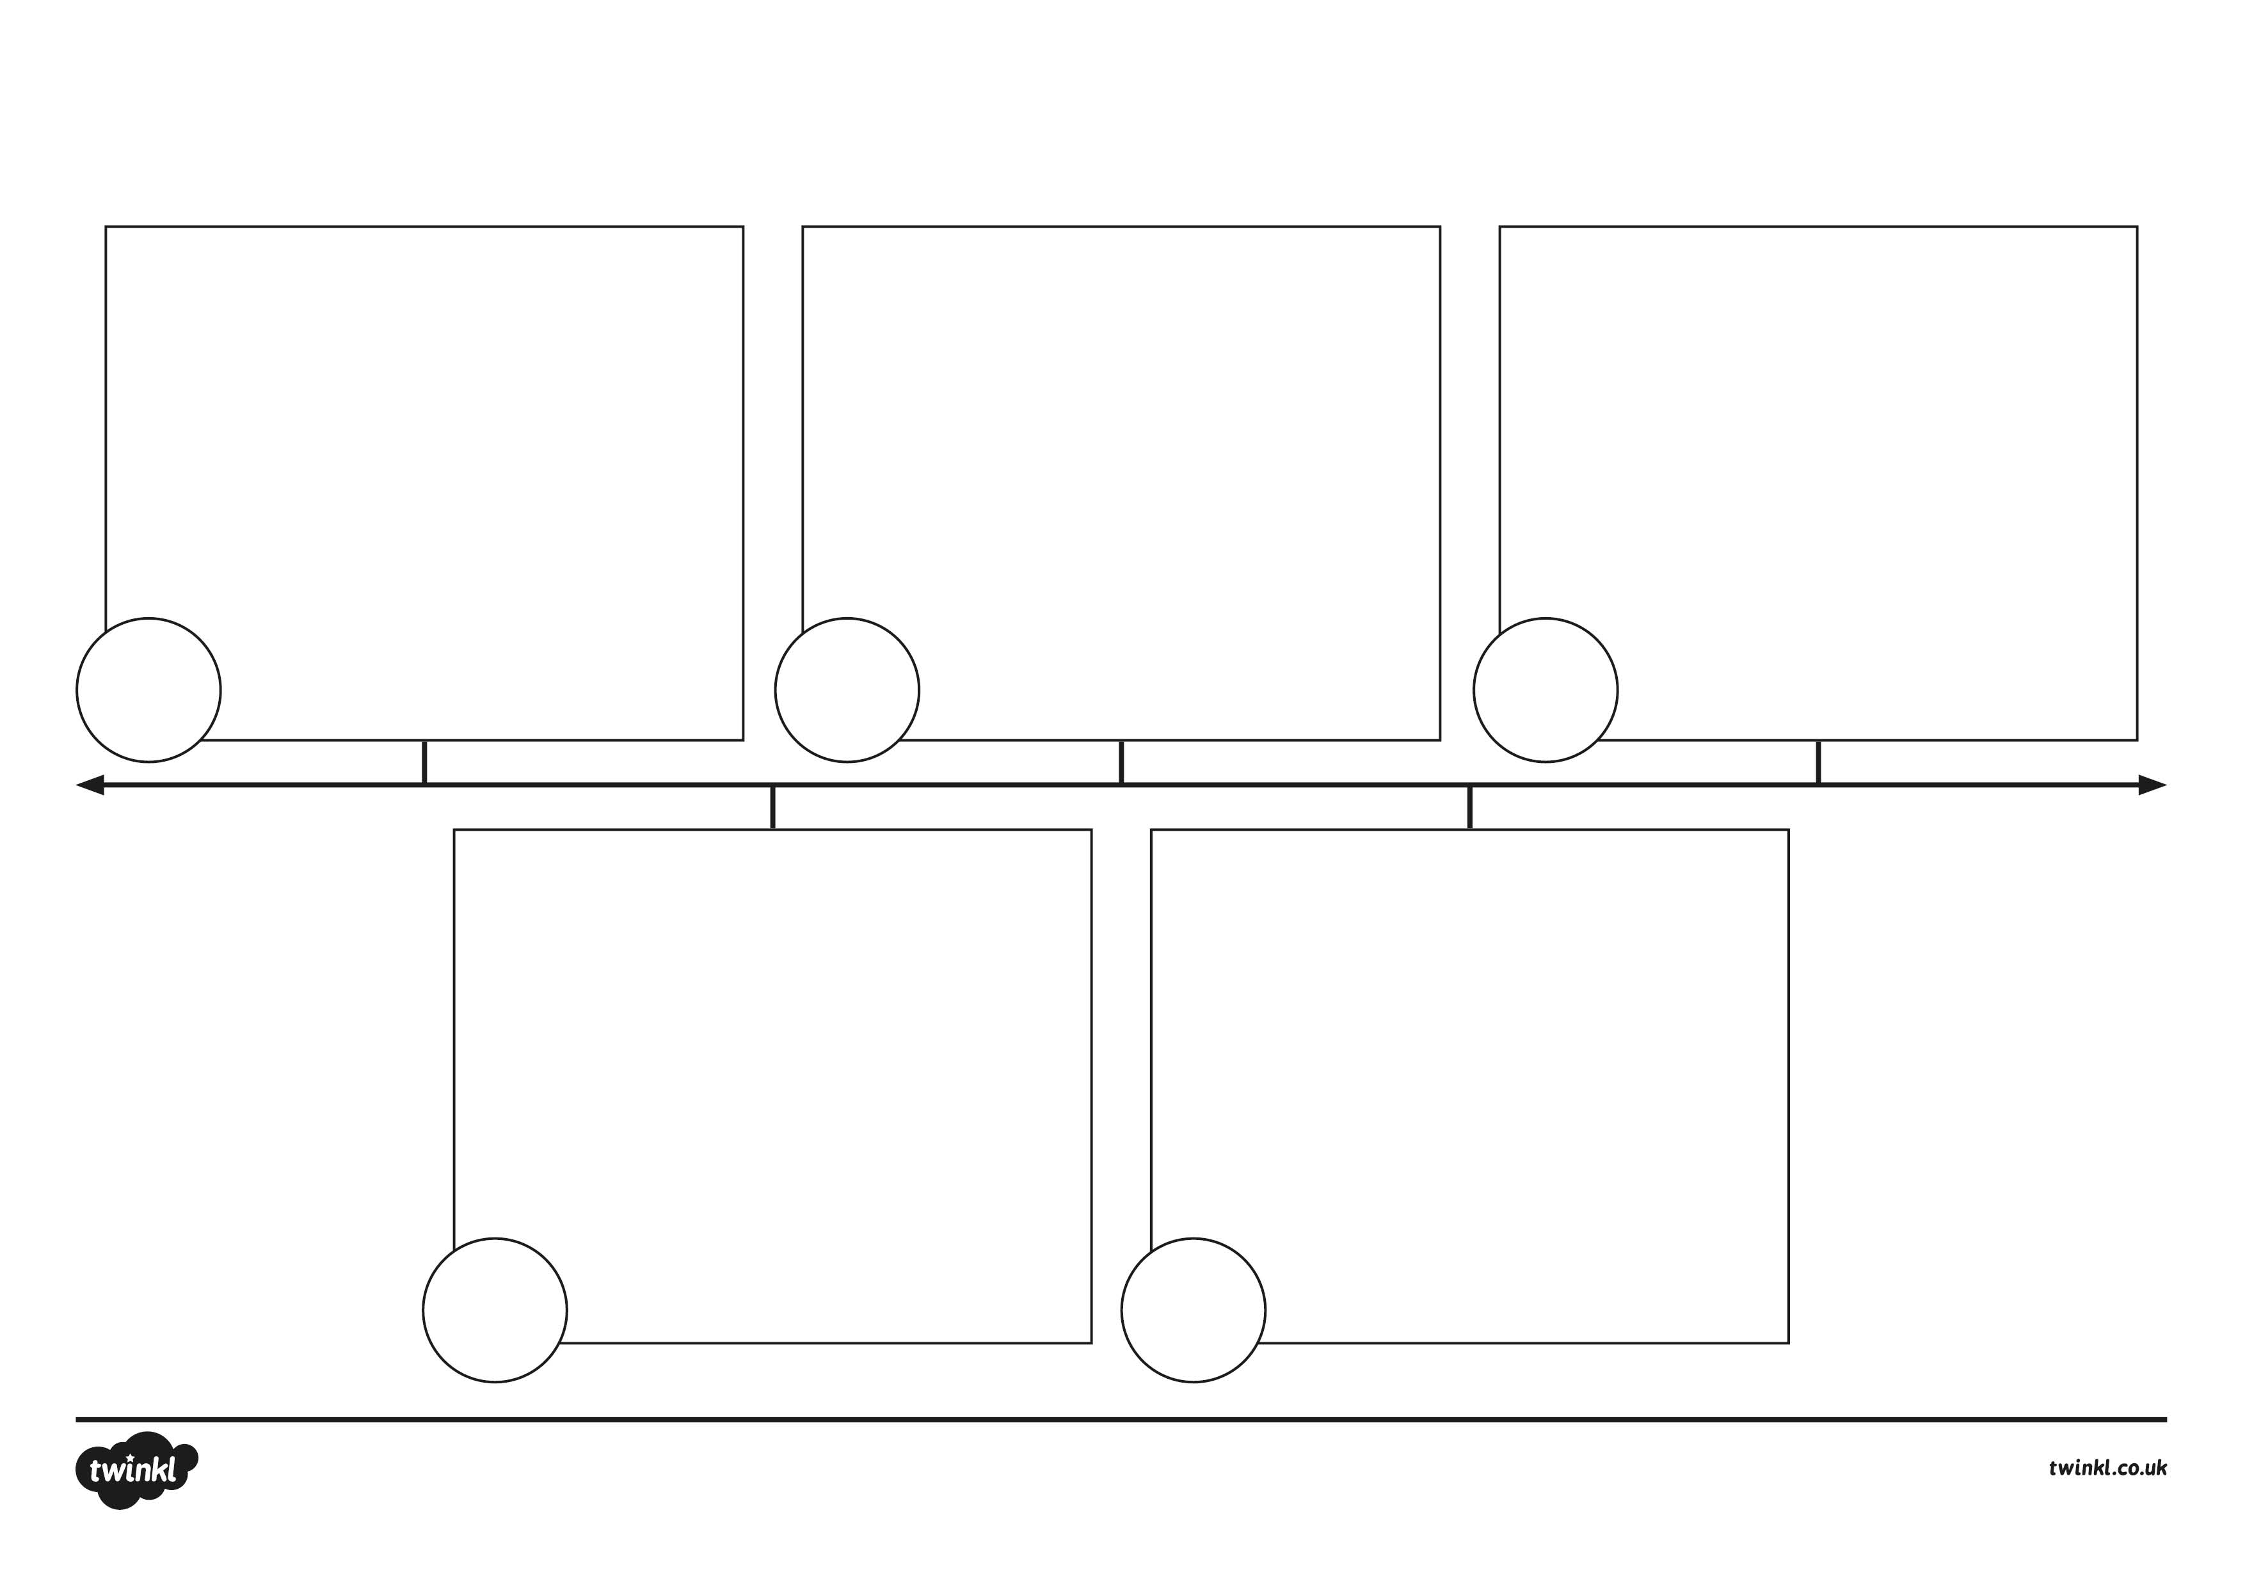
Neil Armstrong Timeline
Event:
Event:
Event:
Event:
Event:
1930
1966
2012
1945
1969
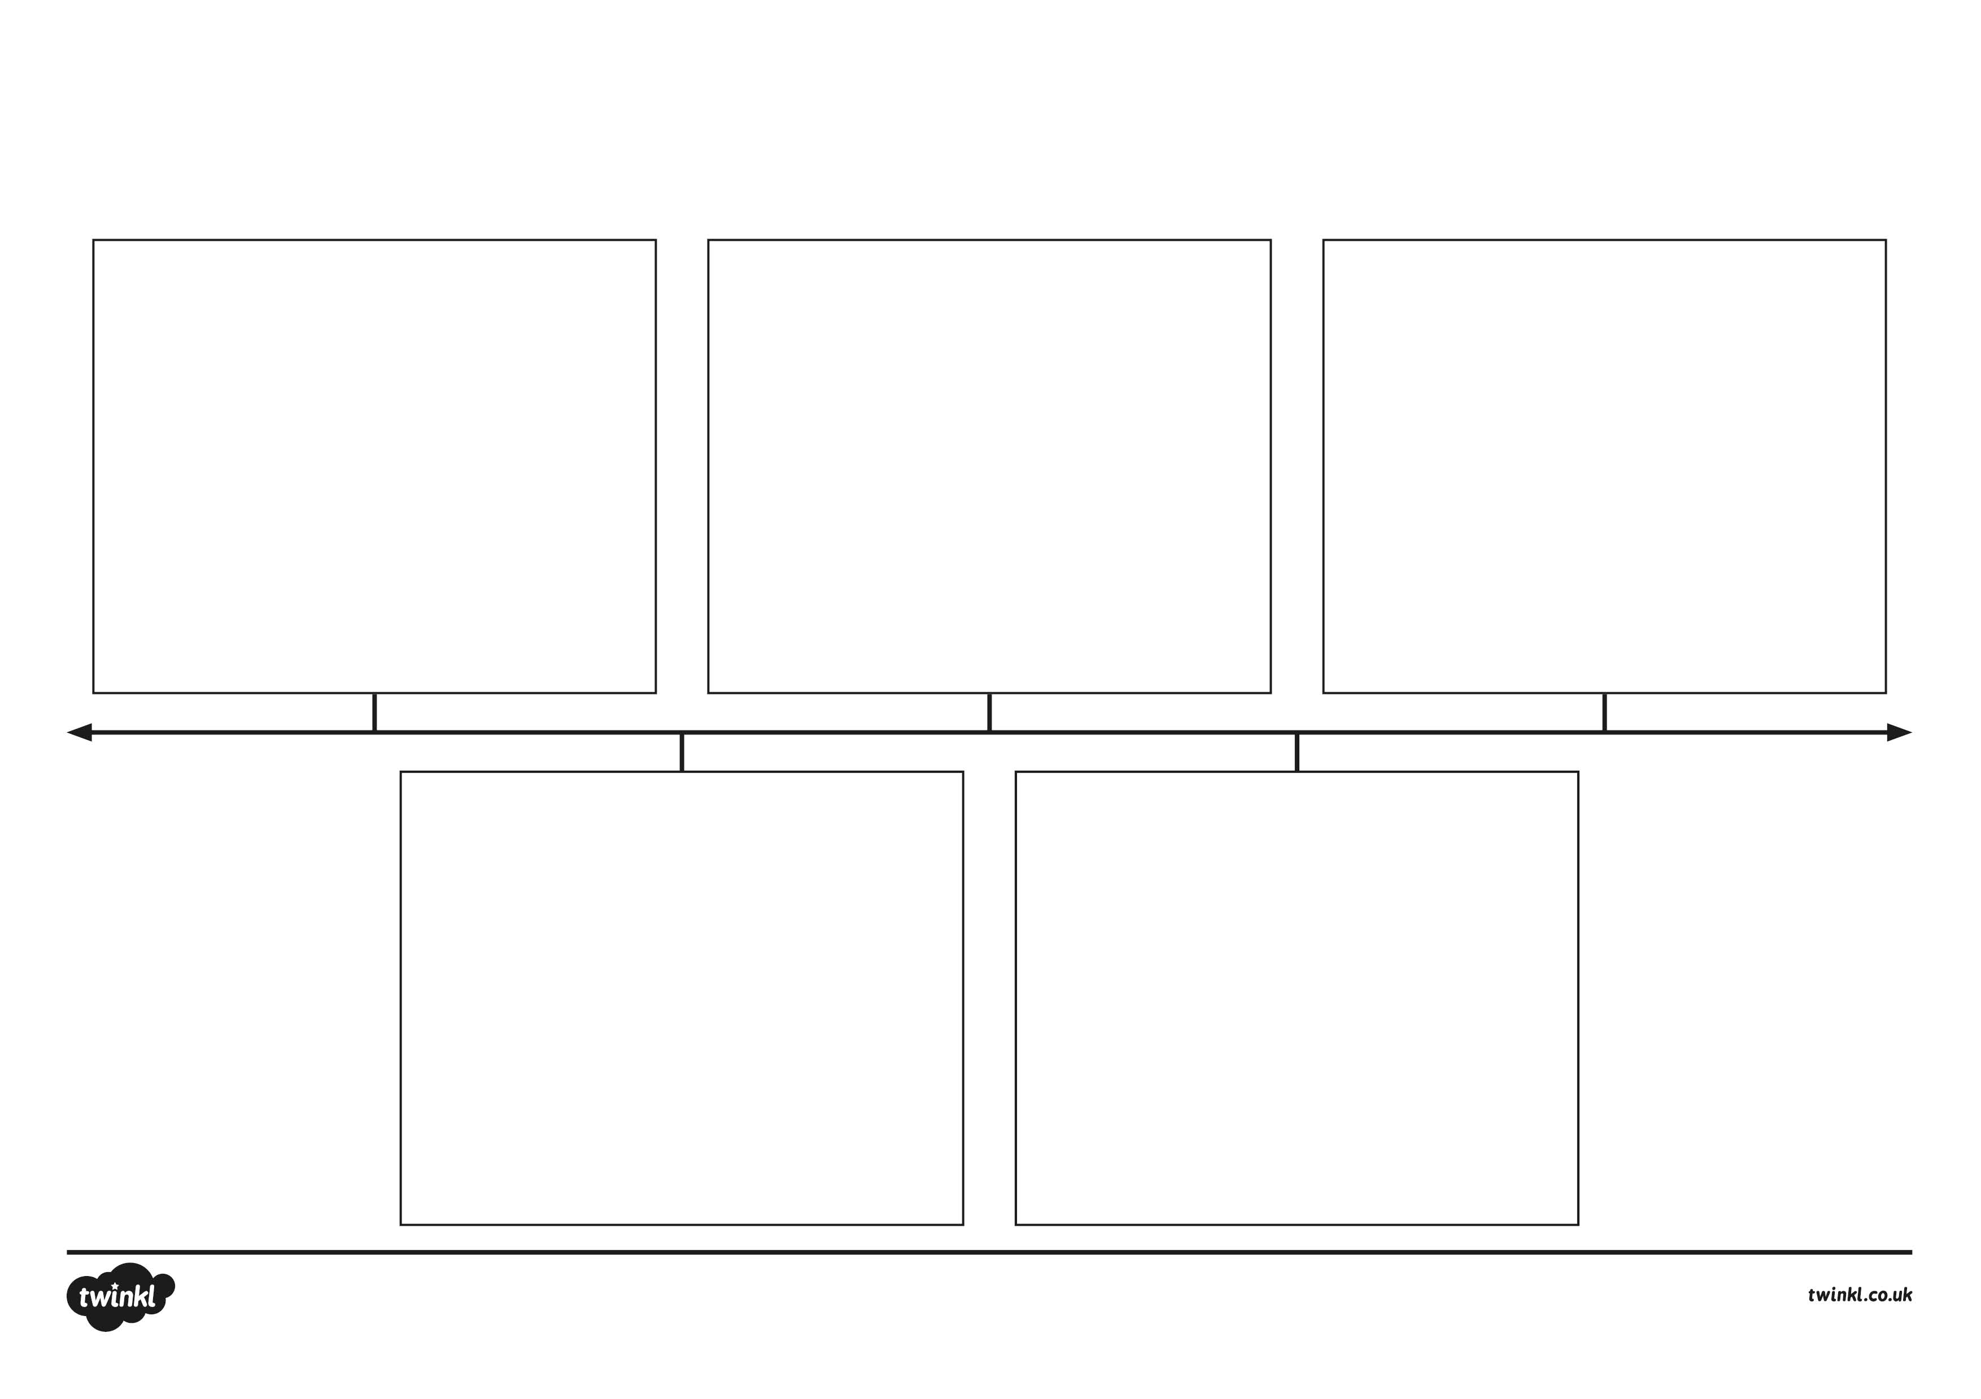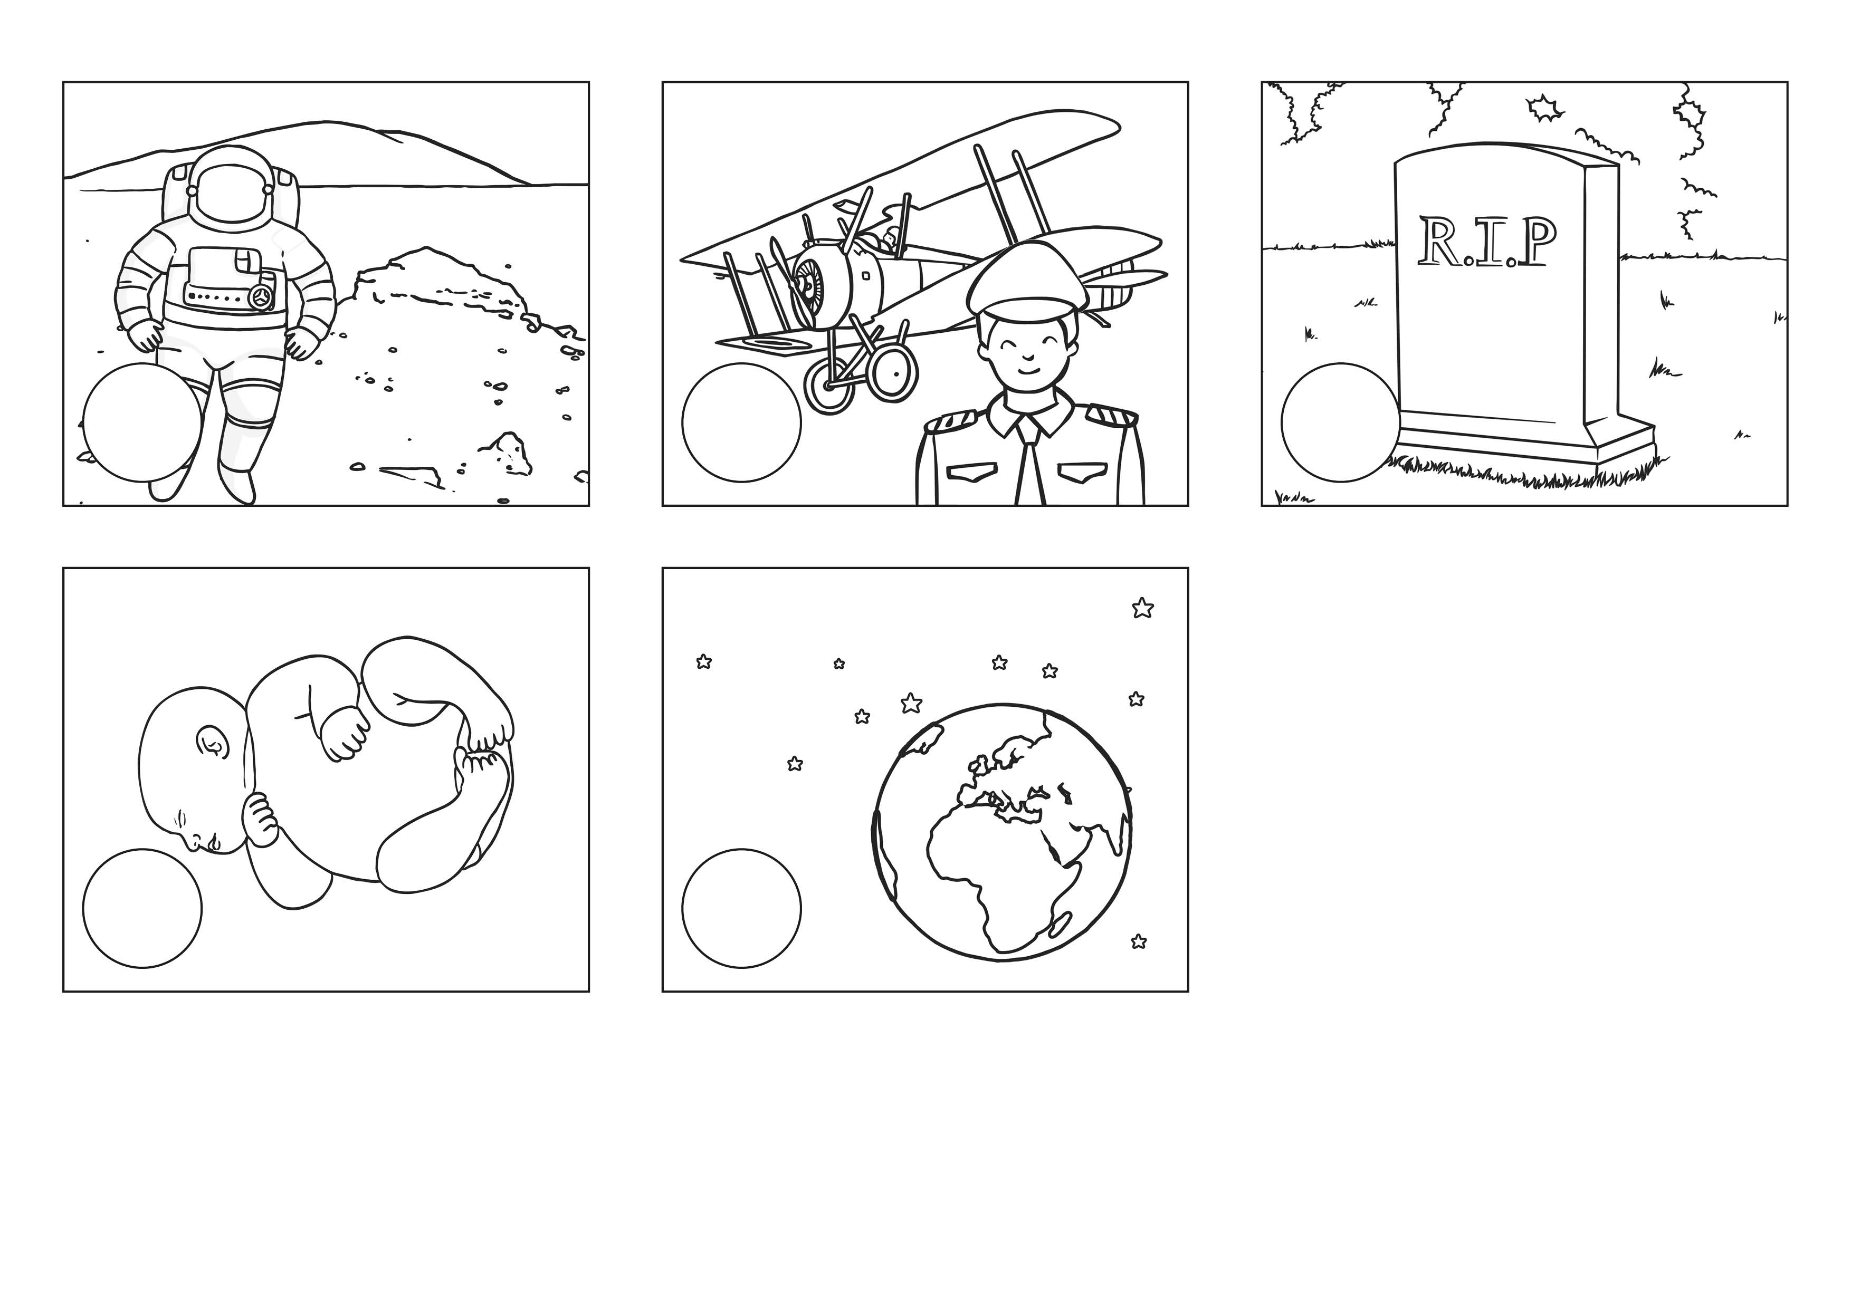
Neil Armstrong Timeline
1930
1966
2012
1945
1969

