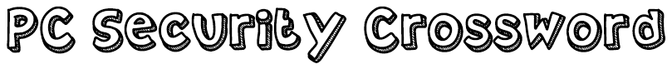

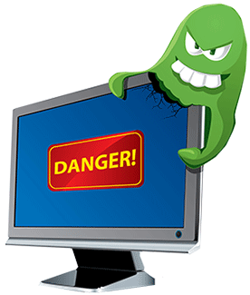

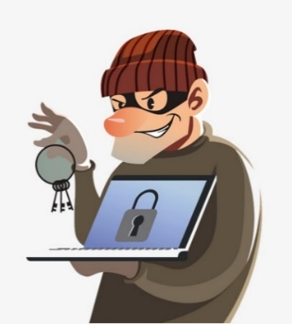

Across
1. The name for scam emails or messages that trick a user into giving out their personal information, e.g. bank details or passwords, often by clicking a web link.
3. A small file used by a web browser to store data about a user's session. Generally not a problem, but web sites can share or track user data this way.
5. One of the world's largest security companies. Well-known for its security products.
6. To be effective, it should contain a mixture of letters, numbers and symbols.
10. This particularly nasty type of spyware attempts to steal personal information and passwords by recording everything you type.
11. Where in the web browser does 'https' appear?
13. The general name for any software designed for malicious (unethical) purposes.
14. Regularly do this, for your security software, programs and operating system.

Down
2. Someone who tries to break into a computer system, usually with bad intentions.
4. What icon identifies a secure website?
7. The name for software that protects your PC against threats. Always use one of these!
8. The 's' in https.
9. Malicious software that tricks a user into installing it by appearing to be a legitimate program or file.
12. Free software that is supported by advertisements, eg. pop-up banners. These can be legitimate or malicious.

