Paint in a bag - Flower
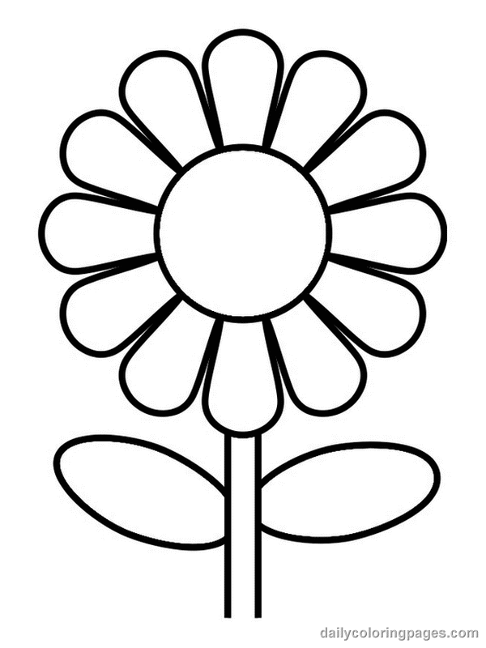
Print me out and put a blob of paint on each of my petals, leaves, bud and stem (different colours). Then place me carefully in a clear plastic wallet or bag. Use your fingers to move the blobs of paint around to fill in all the white.
Paint in a bag - Car
Print me out and put a blob of paint on each of my wheels, windows, and doors (different colours). Then place me carefully in a clear plastic wallet or bag. Use your fingers to move the blobs of paint around to fill in all the white.

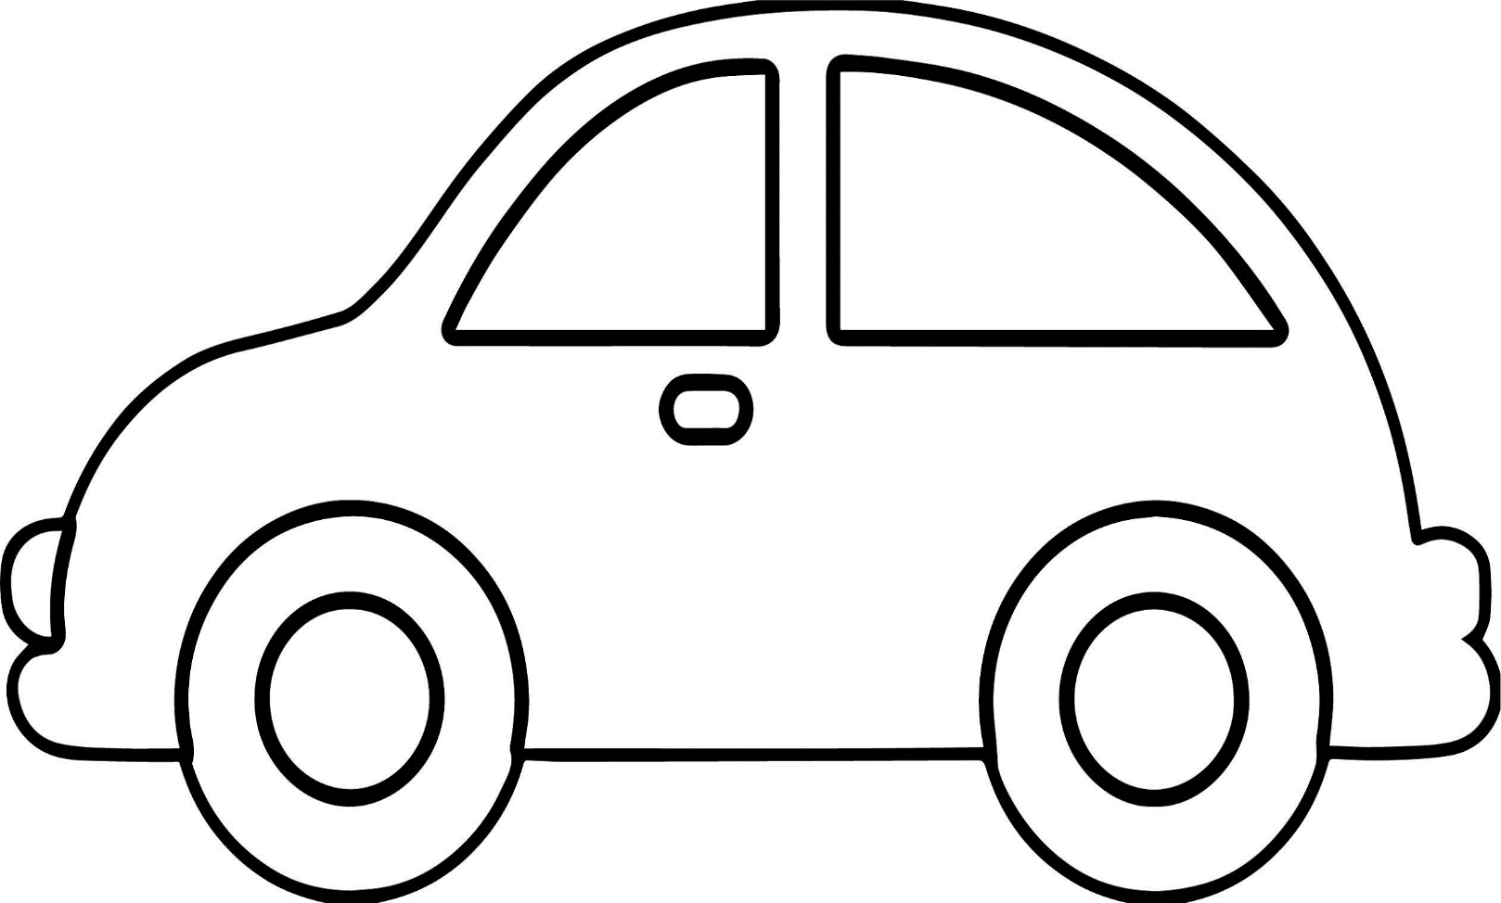

Paint in a bag -Sonic
Print me out and put a blob of paint on each part of my face (different colours). Then place me carefully in a clear plastic wallet or bag. Use your fingers to move the blobs of paint around to fill in all the white.

Paint in a bag - Crown
Print me out and put a blob of paint on each part of my crown (different colours). Then place me carefully in a clear plastic wallet or bag. Use your fingers to move the blobs of paint around to fill in all the white.

