EYFS/KS1 Home Learning
Make your own paper cup bubble machine
Activity 1
Things you will need  - A bendy straw  - Paper cup  - Cellotape  - Water  - Washing up liquid/ bubble bath  All equipment can be swapped for something else that is similar based on what you have at home. | 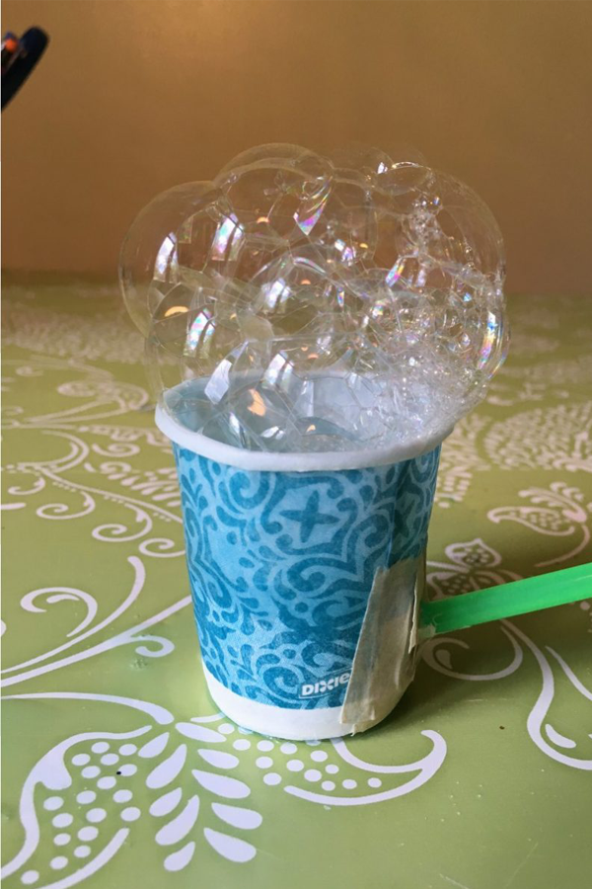  <INSERT PHOTO HERE>
Activity
Ready to put those engineering brains to the test?
This activity demonstrates how we can push air into a container in one area and see it emerge in another area. The straw acts as a tunnel for the air!
Please encourage the pupils to collect their own equipment where possible.
1. Place the straw through the cup somewhere near the bottom
2. Use some cellotape to seal the hole
3. Start blowing into the straw and watch the bubbles form!
4. Experiment with blowing harder or softer, shorter or longer and watch those bubbles grow!

