Pavement painting

Don't have paint at home? Don't worry! We have been having lots of sunshine lately, so why not get out in the sun shine and do some ‘painting’.

What you need:
- Bucket or Bowl of Water
- Paint brush, Sponge, Roller or Water Bottle

What to do:
- Dip your paint brush or sponge into your water and start to ‘paint’ your pavement, try and write your name or draw your favourite shapes.
OR
- Ask an adult to poke some holes into the lid of a water bottle - or if you have a bottle with a squeezy lid that will work. Fill up your bottle of water and squeeze out the water on the pavement until you have made lots of different shapes.
- Then, like magic, the water will evaporate in the sun and disappear, ready for you to do some more pavement painting. ​
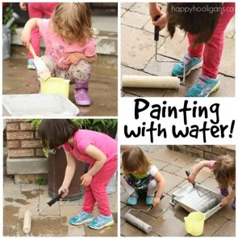
You must remember to wash your hands afterwards with hot, soapy water. ​

