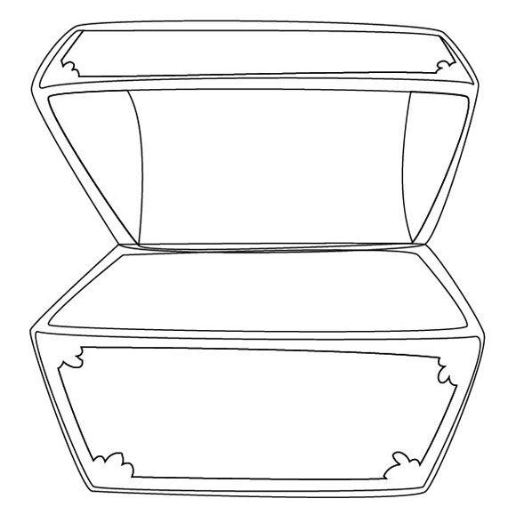

* Pandora’s Box was full of the all of the worst things in the world: War and Famine (hunger), Crime, Cruelty, Sickness, Envy (jealousy), Wickedness… the list goes on!
* What would YOU find in your Pandora’s Box? What are the worst things in the world to YOU?
* Draw a box, use an old box or print off worksheet to complete the activity.