**Pitta Pizza**



|  |  |  |  |  |
| --- | --- | --- | --- | --- |
| Equipment needed: | **Chopping board** | **sharp** **knife** | **tablespoon** |  |
| **C:\Users\rebecca.roberts\AppData\Local\Microsoft\Windows\INetCache\Content.MSO\9D64C226.tmp** |  |  |  |  |
| **1 lge**  Pitta bread | **1 tbsp.** passata | Pinch  Of mixed herbs | **15g**  Grated cheese | Variety of toppings |

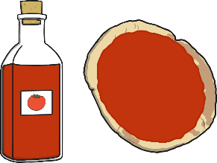

1. Spread passata onto the pitta bread.

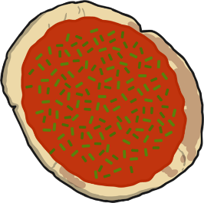

2. Sprinkle some herbs onto the passata

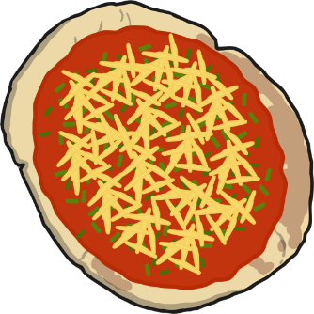

3. Sprinkle some cheese onto the pizza.

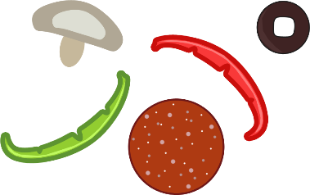

4. Choose some toppings and put them onto the pizza.

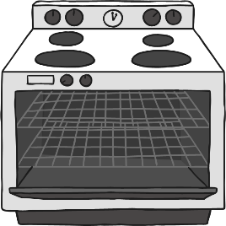5. Put the pizza under the grill.

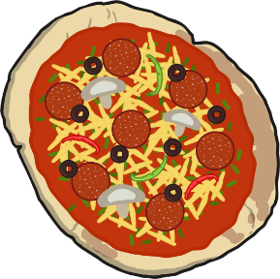

6. When the cheese is bubbling and golden, the pizza is ready.