Purple Mash
Below are instructions on how to access this week’s Science activities on Purple Mash.
Log in to Purple Mash.
Go to the search bar and type Food Chains.
Below is what you should see on your screen.

You should try to complete the activities that are circled. The activities in this section are mixed ability and can all be completed online.
They all focus on food chains and the circle of life. If you complete both activities then move onto the quiz in the ‘Other’ section. Test your knowledge and let your teacher know how you have done.

Go to the search bar and type light quiz.
Below is what you should see on your screen.
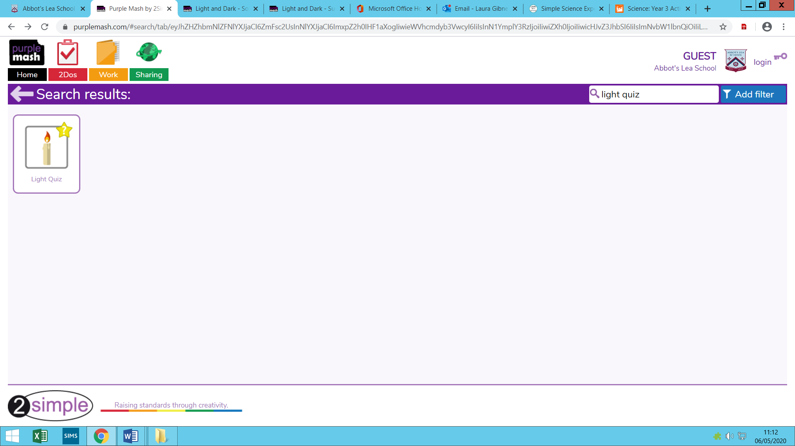

Complete any of the above activities to help support your understanding of light.

