Purple Mash
Below are instructions on how to access this week’s Science activities on Purple Mash.
Log in to Purple Mash.
Go to the search bar and type Magnets.
Below is what you should see on your screen.
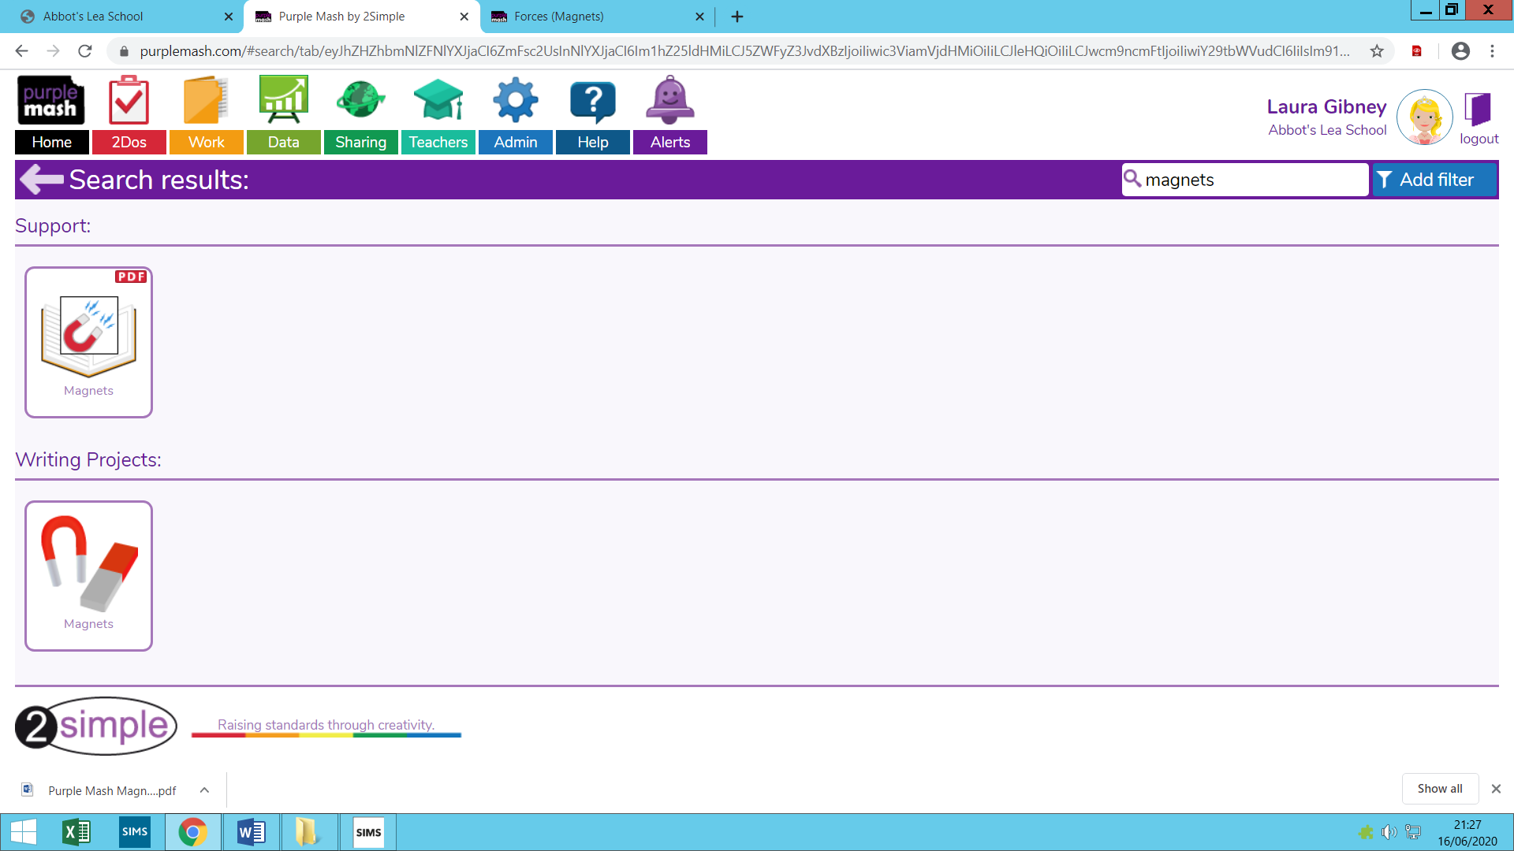

You should try to complete the activity that are circled. This is a writing activity with resources to help you along.

