Purple Mash
Below are instructions on how to access this week’s Science activities on Purple Mash.
Log in to Purple Mash.
Go to the search bar and type light and dark.
Below is what you should see on your screen.
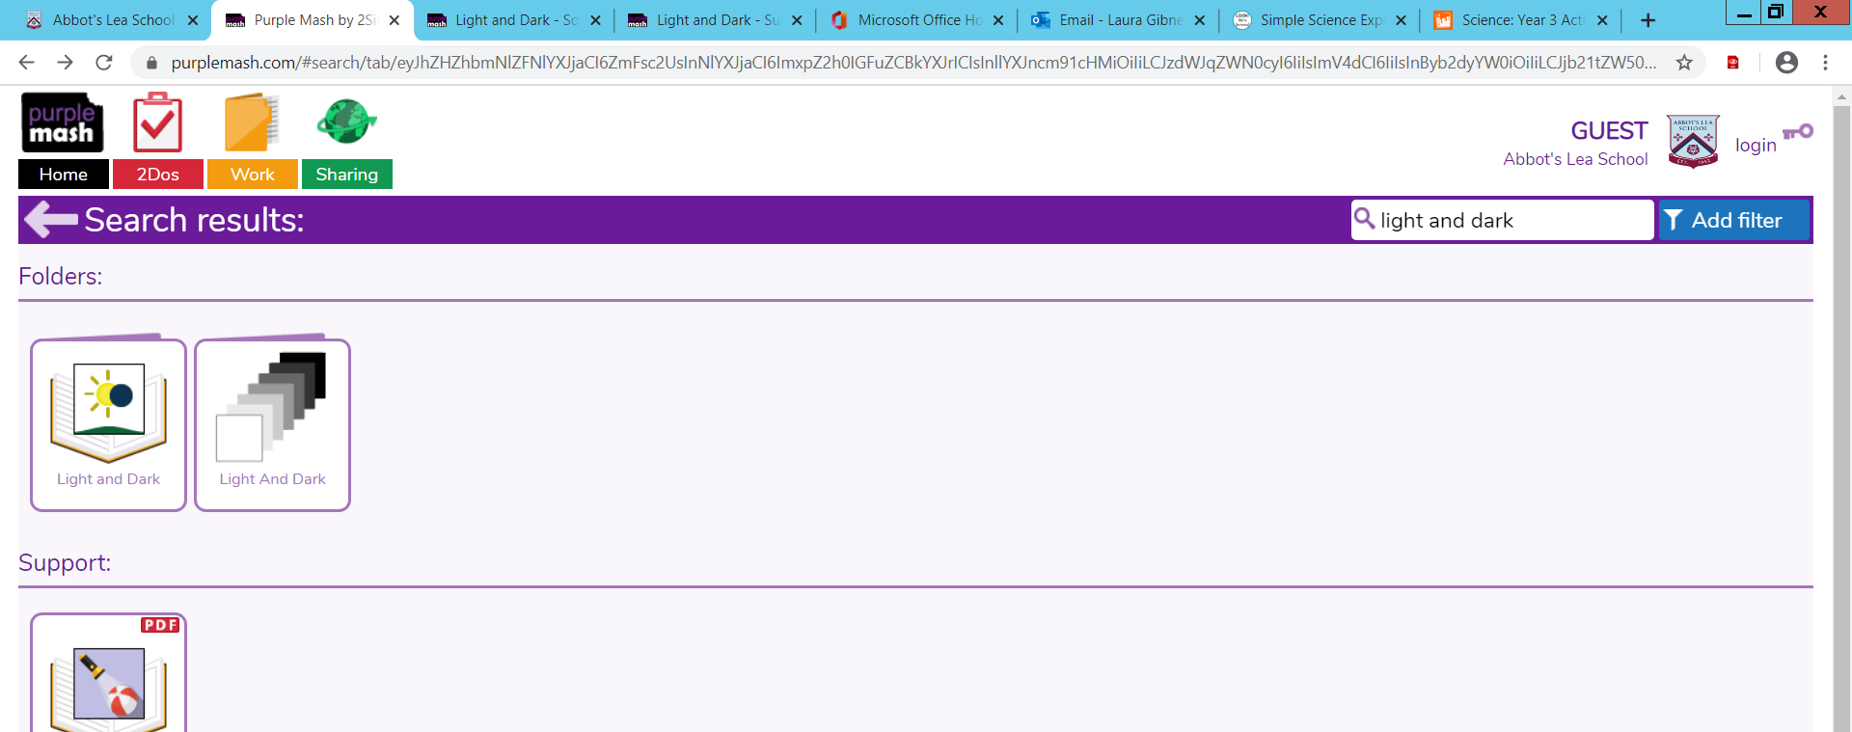

You should try to complete the activities that are circled. The activities in this section are mixed ability and can all be completed online.
If you choose you could also do the following activities…
Go to the search bar and type shadows game.
Below is what you should see on your screen. You can select either game.

Go to the search bar and type light quiz.
Below is what you should see on your screen.
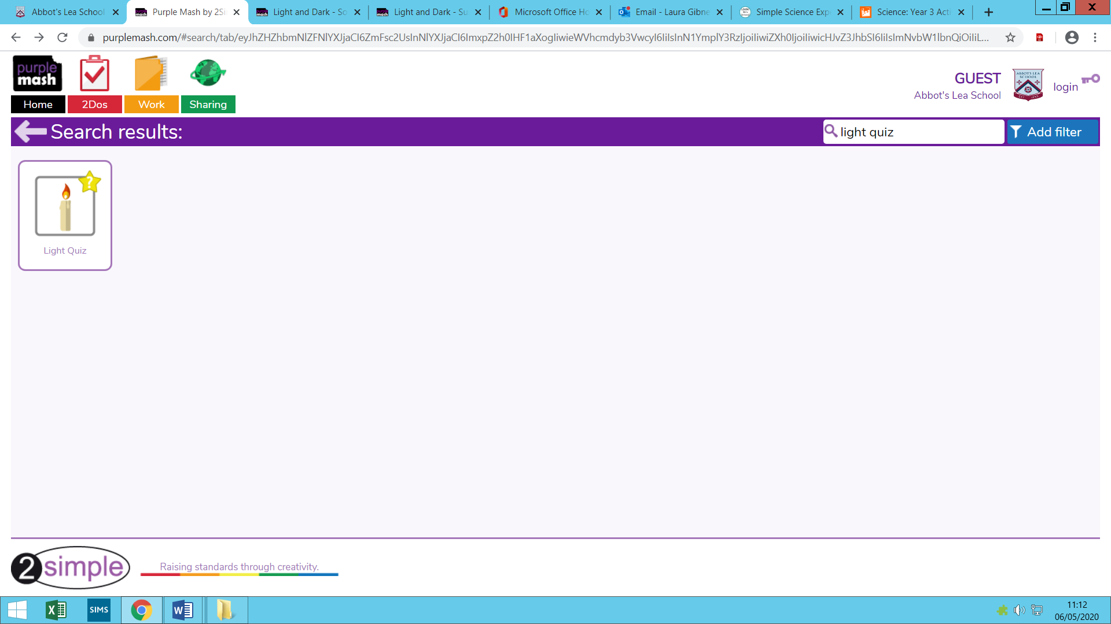

Complete any of the above activities to help support your understanding of light.

