Purple Mash
Below are instructions on how to access this week’s Science activities on Purple Mash.
Log in to Purple Mash.
Go to the search bar and type water cycle.

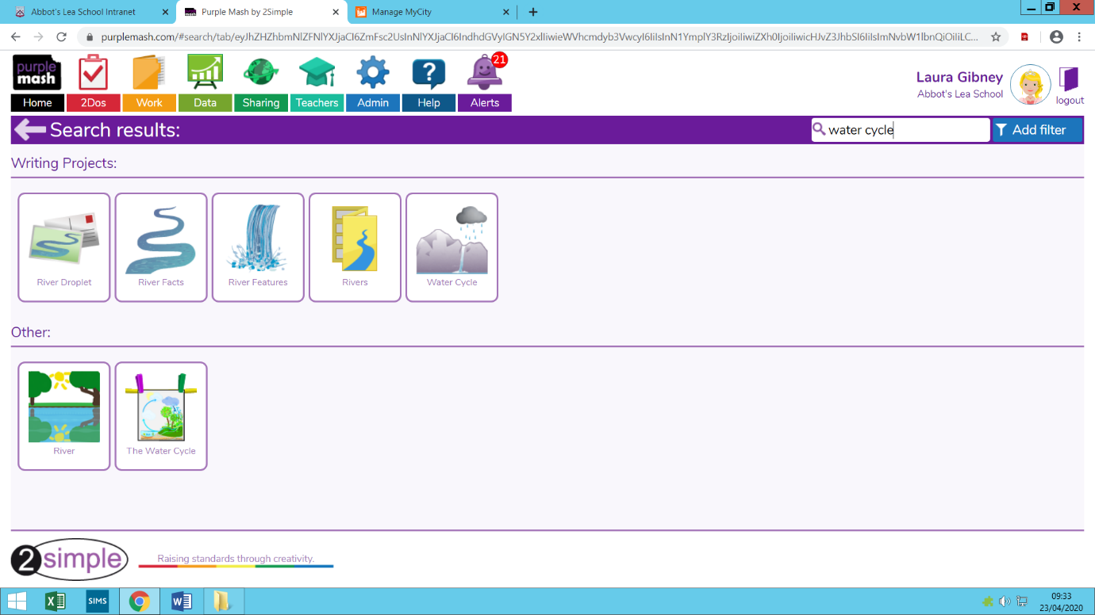
Below is what you should see on your screen.

You should try to complete both of the activities that are circled.
The red circle activity is a writing based task.
The green circle activity is a reading based task where you will be required to complete the missing words.

