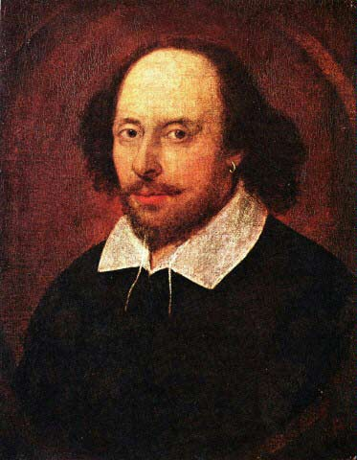
OUTCOME: To conduct independent research, and be able to produce an information sheet.
TASK: To create an informative text about William Shakespeare and the world in which he lived.
You should research the following topics:
- A brief biography of William Shakespeare
- A list of his most popular plays
- The Globe Theatre
- Shakespeare’s London/ Tudor England – this can include things like entertainment, health, daily living, politics, etc.
You may also wish to search the internet. Try using the following search terms in Google:
William Shakespeare AND biography
Tudor London OR Shakespeare’s London
Tudor England OR Shakespeare’s England
Tudor living
The Globe Theatre

