Romeo and Juliet

There have been many adaptations of Romeo and Juliet throughout the years. One of the most popular is the version directed by Baz Luhrman. Here he used the play of Romeo and Juliet and gave it a modern twist.

Imagine you are going to direct your own version of Romeo and Juliet.
What actors would you have playing the characters?
What time would you set it in?
What setting would you give it?
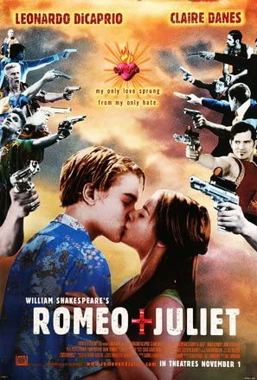
Design a poster or a Powerpoint presenting your version of the film.
Remember to state what actors will be staring and name yourself as the director!
Give your film a slogan.

