My School is Using Zoom to Say Hello to Me and Other Students and Staff

Schools are closed and everyone is staying at home in “Lockdown”. This is to keep us safe and well.
Mr. Mason at Abbot’s Lea wants to say “Hello” to me and check I am ok. He needs to do this on an app called “Zoom”. This means he will be able to see me and I can see him. Mr. Mason may ask other students to use “Zoom” with us too. This is ok.

The most important thing is that Mr. Mason can see me. It’s ok for me to stay quiet and listen. I don’t have to talk if I don’t want to or feel I can’t. Mr. Mason and the other students will understand. They just want to see me and may say “Hello” and ask how I am. I can say “Hello” back or I can give a thumbs up.
I could write some words or use symbols like these to show Mr. Mason and the students how I am. This is ok. Mr. Mason will be pleased and know I am doing my best.

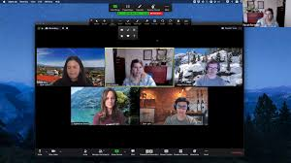
The screen for “Zoom” looks like this with Mr. Mason and the students on it.

Mr. Mason will be pleased to see me on “Zoom”. Its ok to try something new during “Lockdown”.

