Science Experiment at Home

LO: How does condensation work?

Discuss what condensation is

Condensation is the change of water from its gas (water vapor) into liquid water.

How does it work?

Condensation happens in the atmosphere when warm air rises, cools and looses its ability to hold water vapor.
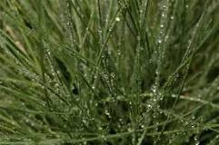
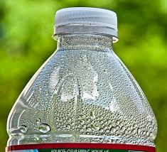
Where might we see condensation?

- Dew on grass in early morning.
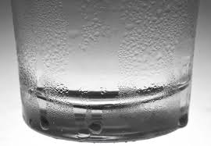
- Glasses fogging up when you walk in warm building on a cold day.
- Water droplets on a glass on a summer-day.

The water cycle

Take a look through the steps of the water cycle.

The water cycle is the process by which water is continuously transferred between the surface of the earth and the atmosphere. In the atmosphere, we can see liquid water droplets in clouds and we can also see ice crystals as clouds too, but these are usually much higher up.

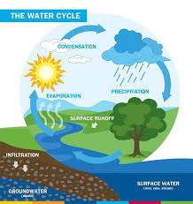

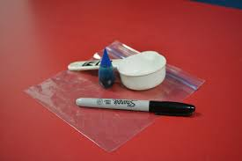
Science Experiment

You will need:

- 1 zip lock bag
- 1 marker
- Tape
- Blue food colouring (optional)

Steps

- Fill the zip lock bag with 0.5 litres of water.
- Zip lock the bag and use your tape to stick to the window securely.
- Once attached to the window and the water has settled carefully apply a line at the top of the water using the permanent marker (without the disturbing the water).

Please note:
- Use blue colouring dye if available to you to help your child see the water more easily
- Each day check back and use your marker to see if water has risen.
LO: To investigate condensation

What are we investigating?
________________________________________________________________________________________________________________________________________________________________________________________________

What equipment will you use?
1.
2.
3.
4.
5.

Variables: What could we change?

1. We could change ________________________________________________________________

2. We are only going to change ________________________________________________________________

Fair Test: What will we keep the same?

1. ________________________________________________________________

2. ________________________________________________________________

Method: What did you do?

Firstly we ________________________________________________________________________________________________________________________________________________________________________________________________

Then we _______________________________________________________________________________________________________________________________________________________________________________________________

Finally we _______________________________________________________________________________________________________________________________________________________________________________________________

Conclusion: What did you find out

I found out ________________________________________________________________________________________________________________________________________________________________________________________________________________________________________________________________________________________________________________________________________________________________________________________________

