Kids Crafts: Homemade Sun Dial

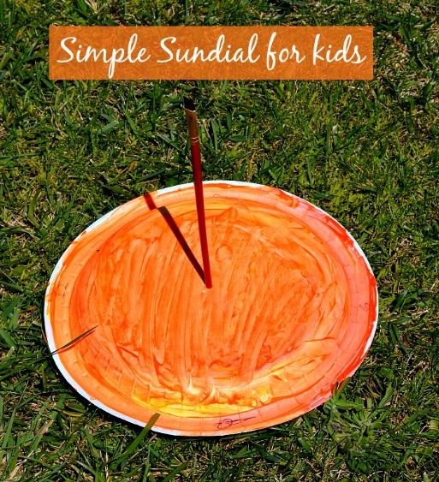

Use paper plates to make a simple sun dial for kids.

With the sun shining bright already we are heading out more and more. Fun kids crafts that can be turned into a great learning opportunity.

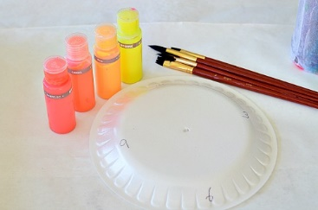Materials

* Paper Plates
* Orange, Red and Yellow Paints
* Paint Brushes

I set out good quality paper plates along with some of our gorgeous neon paints.

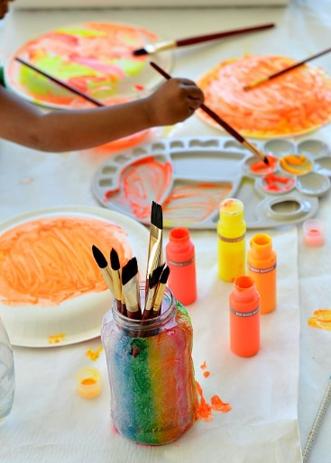

The children mixed and swirled the colours to make their paper plate to look more like the Sun by using more oranges and yellows.

We set out the plates to dry for a while.

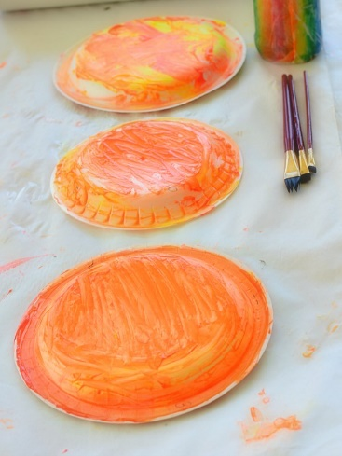

Then comes the fun part. We set out the “sun dials” in our backyard {facing North} where we get plenty of direct sunlight. In the middle of the plate we punched out a hole and attached the paintbrush to stand erect.

The children observed the shadow the brush casted on the plate. We checked the shadow every hour and draw a solid line over the shadow. This activity will turn out great when done on a day you know you will home for the most part. The children will be happy to check out the movement of the shadow.

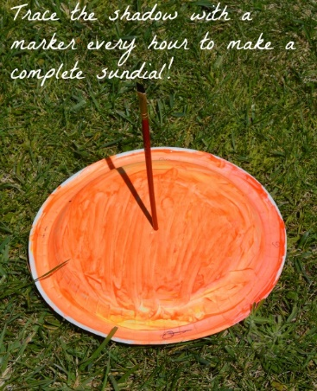Top of Form

Bottom of Form

Top of Form

Bottom of Form