Science

Activity- Sundial shadows

What you will need;
Chalk

Activity;

- Before you go outside and complete the activity can you write a prediction about what might happen to your shadow throughout the day?
- Go outside in the morning and ask someone to help draw around your shadow.
- In the afternoon go back outside and stand in the same spot you stood in, in the morning.
- Ask somebody to help you draw around your shadow again.
- Take a step back and look at both shadows, can you see a difference in the two different shadows?
- Look back at your prediction, was it correct? Remember predictions do not have to be right they are just a guess.
- Challenge: Do you know why the shadows have changed places?
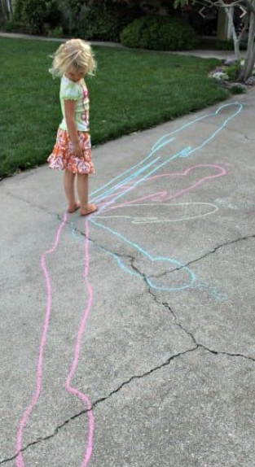

Don’t forget to send a picture to your teacher!

