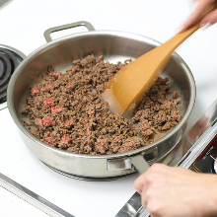
- In a saucepan, heat the mince on a low heat until the fat starts to grease the pan.

- Add the chopped onion, garlic, herbs and salt and pepper to the pan. Stir continuously until the mince is browned.
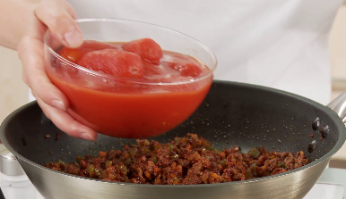

- Add the chopped tomatoes and stir.

- Reduce the heat and simmer.

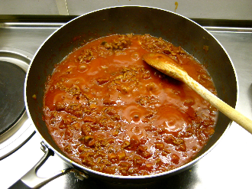
- Allow to cook for about 15 minutes stirring regularly.

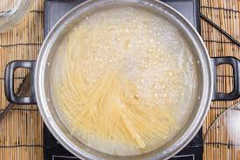
- Boil salted water in another saucepan for your spaghetti. Simmer until tender (12 mins).

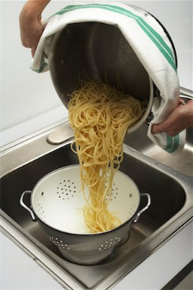
- Drain spaghetti and pour the meat and tomato mixture on top.

