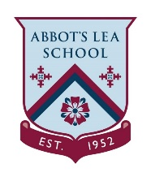
EYFS/KS1 Home Learning
PSHE Activity 1
Things you will need  - Empty plastic drinks bottle/s or empty yoghurt/fromage frais pots  - Playdoh or Dry wipe pens  - Toothbrush  All equipment can be swapped for something else that is similar based on what you have at home. | 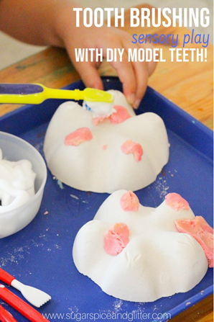  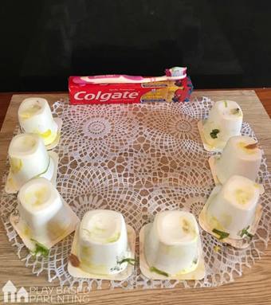
Activity
This activity is to encourage good dental hygiene and gives parents an opportunity to show children how to brush their teeth. Please encourage the pupils to collect their own equipment where possible.

- If using plastic bottles cut the bottom/s off. If using yoghurt pots or more than one drinks bottle arrange these upside down in a semi-circle. These will become the ‘teeth’.
- Use either playdoh or dry wipe markers to add ‘plague’ to the ‘teeth’.
- Using a toothbrush scrub off all the ‘plaque’ to get those ‘teeth’ sparkling!

You can also experiment with letting play dough dry on one tooth and applying fresh play dough to the second tooth to see how cleaning “dried plaque” may differ from cleaning teeth right after food/material build-up.

