Telephone skills

Tips for Getting People to Slow Down! 
One of the biggest problems is speed. Some speakers, especially business people, tend to talk very quickly on the telephone. Here are some practical tips to help ease the pace and ensure good communication.
Immediately ask the person to speak slowly.
When taking note of a name or important information, repeat each piece of information as the person speaks.
This is an especially effective tool. By repeating each important piece of information or each number or letter as the spell or give you a telephone number you automatically slow the speaker down.
- Do not say you have understood if you have not. Ask the person to repeat until you have understood.
Always make the speaker aware if you have any hearing or language difficulties.
- Remember to be confident and not afraid to be yourself
One of the biggest barriers to using the telephone is low self-esteem. It is important not to worry about what the other person thinks or fear saying the “wrong” thing.
The person at the other end of the phone does not know anything about you.
No one can judge you for being yourself, and companies are not there to label you as “slow” or “stupid”. Any difficulties in communication should be resolved by both parties, and the other person has as much responsibility as you in this matter!
In a way, telephone communication should be easier than face-to-face communication, as you don’t need to worry about eye contact or body language (or blushing!)



Leaving a Message
Sometimes, there may not be anyone to answer the telephone and you will need to leave a message. Follow this outline to make sure that the person who should receive your message has all the information he/she needs.
- Introduction - - - - Hello, this is Ken. OR Hello, My name is Ken Beare (more formal).
- State the time of day and your reason for calling - - - - - It's ten in the morning. I'm phoning (calling, ringing) to find out if ... / to see if ... / to let you know that ... / to tell you that ...
- Make a request - - - - Could you call (ring, telephone) me back? / Would you mind ... ? /
- Leave your telephone number - - - - My number is .... / You can reach me at .... / Call me at ...
- Finish - - - - Thanks a lot, bye. / I'll talk to you later, bye.

Here's an example of a message
Telephone: (Ring... Ring... Ring...) Hello, this is Tom. I'm afraid I'm not in at the moment. Please leave a message after the beep..... (beep)
Ken: Hello Tom, this is Ken. It's about noon and I'm calling to see if you would like to go to the Mets game on Friday. Could you call me back? You can reach me at 367-8925 until five this afternoon. I'll talk to you later, bye.
As you can see, leaving a message is pretty simple. You only need to make sure that you have stated all the most important information: Your Name, The Time, The Reason for Calling, Your Telephone Number
Telephone English - Important Phrases
As you can see, the language is rather informal and there are some important differences to everyday English:
Introducing yourself
This is Ken.
Ken speaking
Asking who is on the telephone
Excuse me, who is this?
Can I ask who is calling, please?
Asking for Someone
Can I have extension 321? (extensions are internal numbers at a company)
Could I speak to...? (Can I - more informal / May I - more formal)
Is Jack in? (informal idiom meaning: Is Jack in the office? )
Connecting Someone
I'll put you through (put through - phrasal verb meaning 'connect')
Can you hold the line? Can you hold on a moment?
How to reply when someone is not available
I'm afraid ... is not available at the moment
The line is busy... (when the extension requested is being used)
Mr Jackson isn't in... Mr Jackson is out at the moment...
Taking a Message
Could (Can, May) I take a message?
Could (Can, May) I tell him who is calling?
Would you like to leave a message?

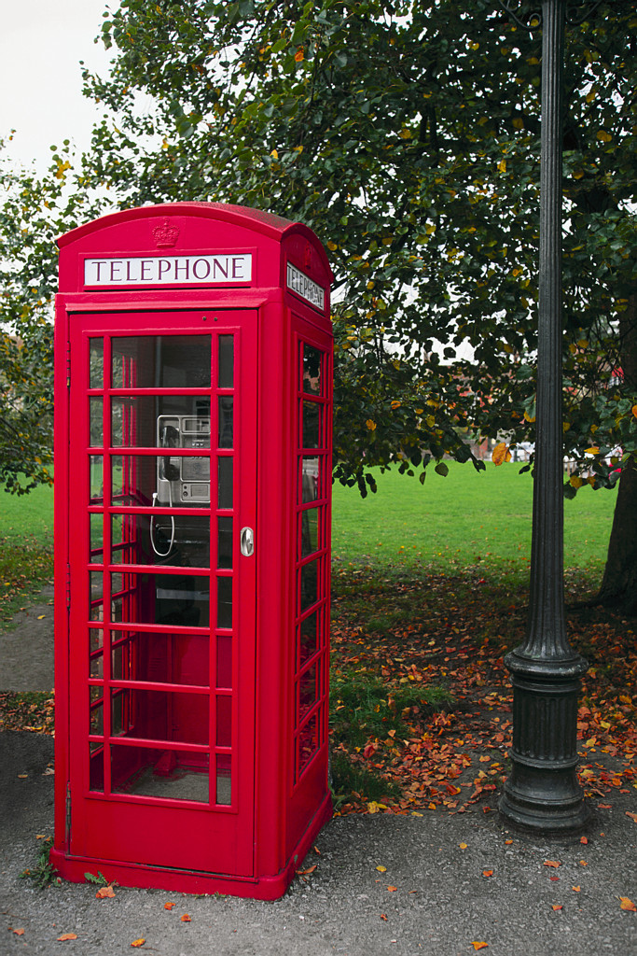

Exercises for Practicing Speaking on the Telephone
The most important thing about practicing telephone conversations is that you shouldn't be able to see the person you are speaking to on the phone. You may ask, 'How can I do that if I am practicing with a friend or another classmate?' Here are a few suggestions for practicing phone calls without looking at your partner:
- If you are in the same room - Put your chairs back to back and practice speaking on the phone, you will only hear the other person's voice which will approximate a telephone situation.

- Real life situations - Businesses are always interested in telling you about their products. Find a product you are interested in and research it over the telephone. You can ...
  - call a store to find out the opening hours
  - ring a company representative to find out details about a product
  - set up telephone banking and talk to an adviser rather than visit a branch
  - call your mobile phone provider to ask about special customer offers

