Time keeping and attendance

Watch the clip to support you, but you can discuss your answers with someone at home if you need help: https://www.youtube.com/watch?v=MG73sn4HGao

- You can make money; you can’t make time.

- An inch of gold cannot buy an inch of time (Chinese proverb).

Time management matrix-classification of activities

Urgency and importance | Urgent | Not urgent
Important

Not important
Number 1-4 in the box above with how important a task should be completed with the number 1 being the most important.
Why is it important to manage you time?

To utilise the available time in optimum manner to achieve one’s personal and professional goals.
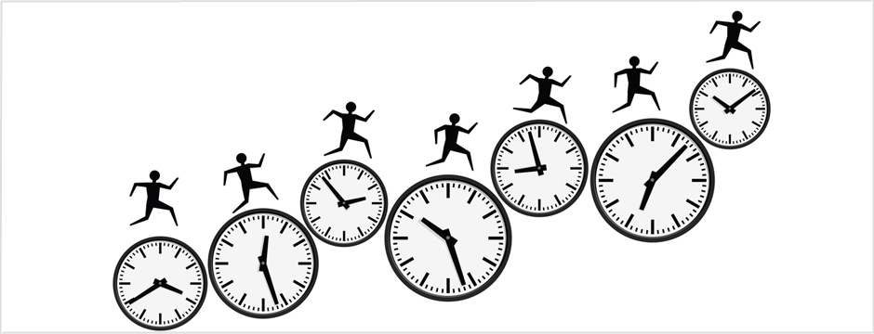

Describe good timekeeping

Describe good attendance

State the requirement for timekeeping and attendance in our school

Describe what to do if late or unable to attend.

- Planning is key managerial function but research shows that less than 5% of management time goes on planning.

- Pareto Principle (80/20 Principle):
Twenty percent of your time will produce 80% of your productive output.
Can you afford not to manage at-least that 20% ?
- Parkinson’s Law:
Work expands to fill the time available for it. Beware!
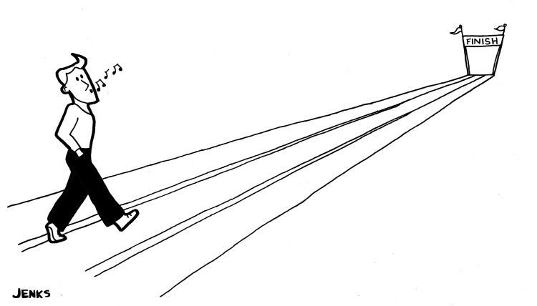

Remember that communication is key

