**Victoria Sandwich Cake**

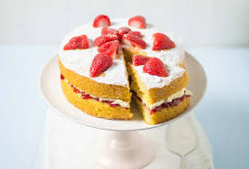

**This one will take bit longer but worth it!**

**Preparation time: 30 minutes**

**Cooking time: 20 minutes**

**Ingredients for the cake**

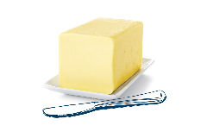

175 g (6 oz) butter, at room temperature

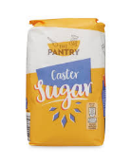

175 g (6 oz) caster sugar

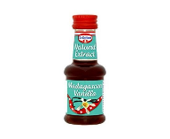

Teaspoon of vanilla essence

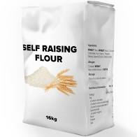

175 g (6 oz) self-raising flour

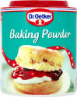

1 teaspoon baking powder



3 medium eggs, beaten

**Filling**

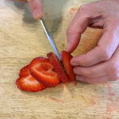

150 g (5 oz) strawberries, sliced

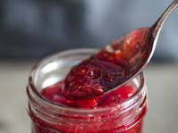

3 tablespoons strawberry jam



150 ml (1/4 pint) double cream



4 strawberries to decorate,

**Method**

1. Preheat the oven to 180oC/350oF/Gas Mark 4.  Lightly brush the base and sides of 2, 20 cm (8 inch) Victoria sandwich tins with a little oil then line the bases with 2 circles of non-stick baking paper the same as the base of the tins.
2. Mix the butter and sugar together in a large mixing bowl with a wooden spoon or in an electric mixer until light and fluffy then stir in the vanilla extract.
3. Sift the flour and baking powder on to a plate. Gradually beat alternate spoonfuls of beaten egg and flour into the creamed butter mixture until smooth, continue until all the eggs and flour have been added.
4. Divide the mixture between the tins, spread level with a round bladed knife then cook on the middle shelf in the oven for about 20 minutes until well risen, golden brown and the cake springs back when lightly pressed with a fingertip. Allow to cool for a few minutes then loosen the edges of the cakes with a round bladed knife and turn out on to a large wire rack. Peel off the lining paper then turn cakes back up the other way and leave to cool completely.
5. Mix the sliced strawberries with the jam, if the jam is very set, warm briefly in the microwave before adding the strawberries. Softly whip the cream. Transfer one of the cakes to a serving plate. Top with spoonfuls of the cream then the strawberry jam mix. Carefully lift the top cake in place, arrange the halved strawberries on top and sprinkle with sugar. Serve cut into wedges.

