WORD HOPSCOTCH
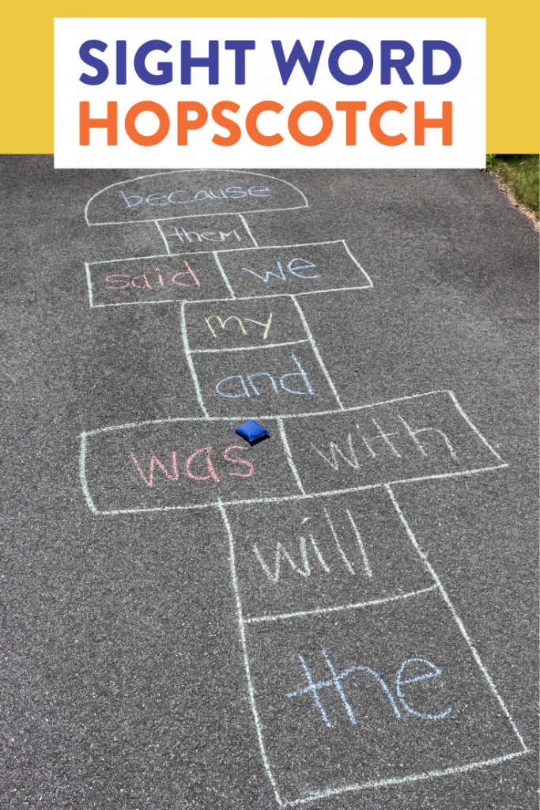

You will need:
Chalk
Marker (bottle cap or bean bag) etc.

Instructions
- Draw grid (as above) 10 squares
- Wright in each box words (as above)
- Direct in front the first player
- First player drops/throws marker in the first box.
- Say word or go to back of line if marker has not landed in the box.
- Hops over all the way to end of grid, turn back hop to marker.
- On one foot pick up marker and hop back to beginning.
- Take turns.

Rules
. marker not landed in box go to end of line
. cannot put foot outside box
. first person to make through all ten boxes is
the Hopscotch winner!

