Resources for Maths
Oak National Academy
https://www.thenational.academy/
Daily maths lessons for years 7 – 10

UKMT are tweeting a problem of the day which are useful to look at. #UKMT
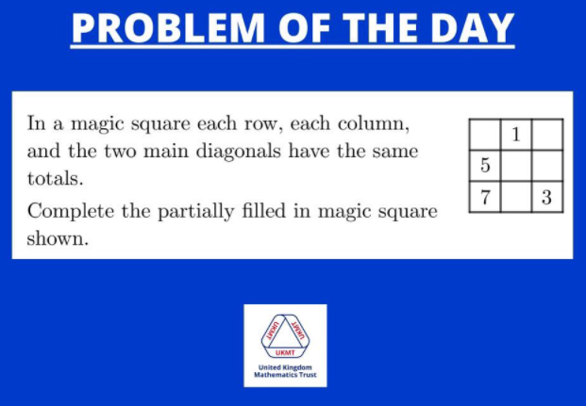
Here was the first one they did on the 23rd March. And the solution is:
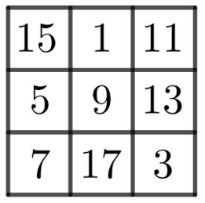

https://www.startingpointsmaths.com/
A really useful website with ideas on all areas of maths that stimulate deeper thinking. New ideas get added each day.

https://whiterosemaths.com/homelearning/summer-term/
White Rose works closely with the BBC Bitesize Daily Maths team to make a clear learning plan for the summer term. Here is a 12-week learning plan, that means children can:
- make sure they understand the main concepts they need for their work next year
- cover any new learning that they have not yet have done in school.

The 12-week plan
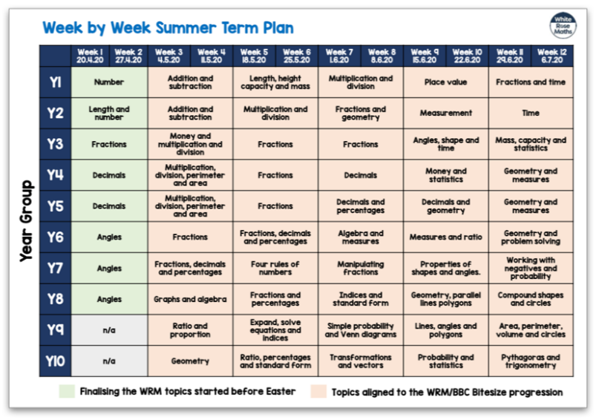
The plan shows the work that children will cover, week by week.
They have already published two weeks of White Rose Maths summer term learning on our Home Learning web page. Some of this differs a little from the BBC Bitesize plan – but only for the first two weeks. From Week 3 onwards, their plans run in line with each other.
This means that every day, there’s a learning video on the web page to watch and a link to that day’s BBC Bitesize page for more information and even more lesson content.

