**Writing Challenge 2**

You have just found an old suitcase in your attic. Describe what you found inside.

Think about:

* How old are the objects?
* Who might this suitcase have belonged to?
* Describe what the objects look like.

Check:

* Capital letters and full stops
* Check your spelling in a dictionary
* Include some interesting adjectives?

**Writing Challenge 1**

Describe what an autumn tree looks like.

Think about:

* The colours
* The textures
* The sounds

Check:

* Does each sentence make sense?
* Full stops and capital letters
* Have I included some interesting adjectives?



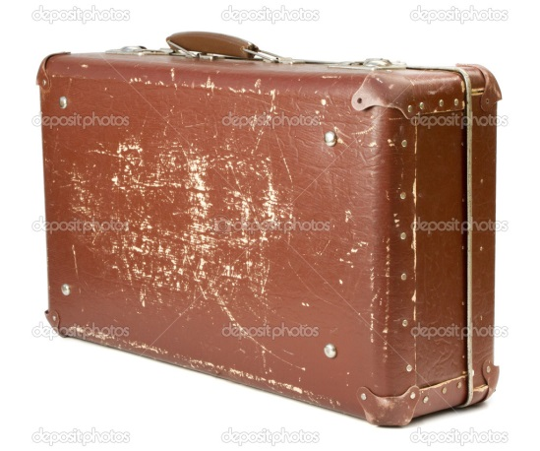

**Writing Challenge 4**

Write a paragraph about if your toys were alive, what they would do whilst you are sleeping.

Think about:

* What might they say to each other?
* Where might they go?
* What might they do?

Check:

* Capital letters and full stops
* Does your sentence make sense?
* Have you used speech marks?

**Writing Challenge 3**

Write a list of 10 exciting words beginning with t. Choose some of these words and put them in a sentence.

Think about:

* What do the words mean?
* How could you use the word in a sentence?
* Choosing some long words and some short

Check:

* Capital letters and full stops
* Check your spelling in a dictionary
* Include some interesting adjectives?



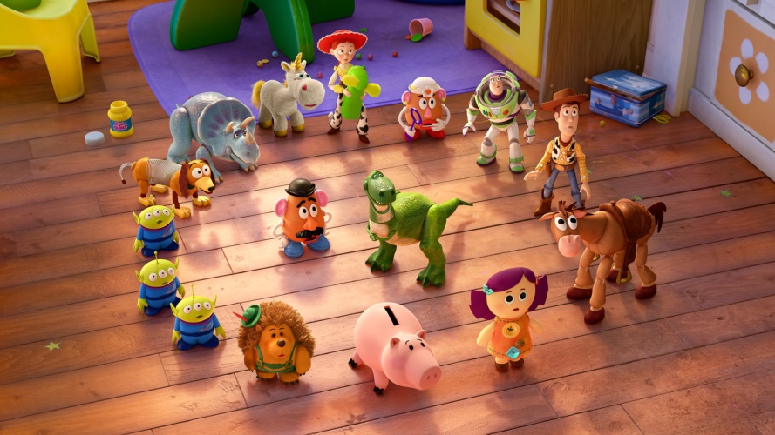

**Writing Challenge 6**

If an alien visited Earth for the day, what would you do with him?

Think about:

* Where would you take him?
* What would you do together?
* How would you talk to him?

Check:

* Capital letters and full stops
* Does your sentence make sense?
* Have you described what the alien

looks like?

**Writing Challenge 5**

Describe your ideal holiday.

Think about:

* Where might you go?
* What would you do?
* Who would you go with?

Check:

* Capital letters and full stops
* Does your sentence make sense?
* Have you explained why it would be

your ideal holiday?

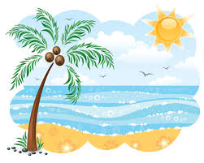



**Writing Challenge 8**

Write a letter to yourself in the future about what you hope you will be doing in 10 years time.

Think about:

* What job would you have?
* Where would you be living?
* Who would be your friends?

Check:

* Capital letters and full stops
* Does your sentence make sense?
* Have you put who the letter is to and from?

**Writing Challenge 7**

Write a list of your favourite foods.

Think about:

* What is your favourite meal?
* What is your favourite snack?
* What is your favourite cake?

Check:

* Capital letters and full stops
* Does each sentence make sense?
* Have you described the food?





**Writing Challenge 10**

Write a story using this sentence starter:

The clock stopped. It was 74 minutes past 18, it was time to get up.

Think about:

* Why is the time very strange?
* Where could the story take place?
* Who might live in this strange place?

Check:

* Does every sentence make sense?
* Have you written it in the third or first person?
* Capital letters and full stops

**Writing Challenge 9**

Choose a picture of a setting from the box and write a paragraph to describe it. Pretend you are standing there.

Think about:

* Writing in first person
* Where could it be?
* What adjectives can you use?

Check:

* Does every sentence make sense?
* Have you used exciting adjectives?
* Capital letters and full stops



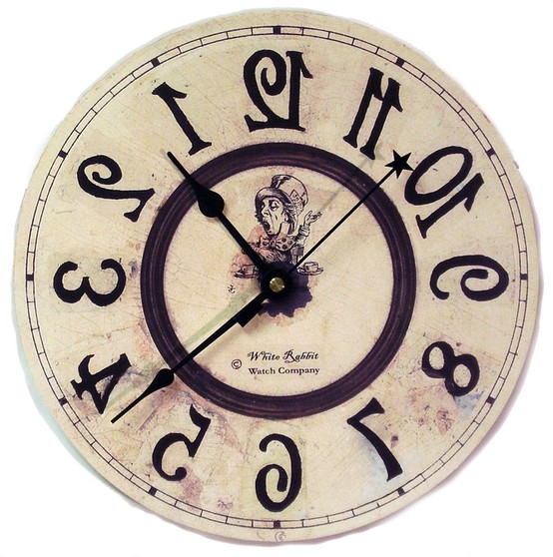

**Writing Challenge 11**

Write a story with this as the title: It was the day the moon fell.

Think about:

* Why did the moon fall?
* Who found out that the moon had fallen?
* Did they manage to get it back in the sky again?

Check:

* Does every sentence make sense?
* Have you written it in the third or first person?
* Capital letters and full stops

**Writing Challenge 12**

Write a short story with this sentence starter: I woke up suddenly, there was something in my room. It burst out of the wardrobe.

Think about:

* What was in your wardrobe?
* How did it get there?
* Was it evil or good?

Check:

* Capital letters and full stops
* Does every sentence make sense?
* Have you written it in the first person?





**Writing challenge 13**

You're washed up on a desert island. What three items do you desire the most and why?

Think about:

* What you might need on the island.
* What you might wish for on the island.
* What home items you might miss.

Check

* Capital letters and full stops.
* Have you explained why?
* Does each sentence make sense?

C:\Users\Sporle J\AppData\Local\Microsoft\Windows\Temporary Internet Files\Content.IE5\1B173RIP\MC900350355[1].wmf

**Writing challenge 14**

A parcel has been accidentally sent to your home. You have to keep it for the weekend before sending it back to the post office. You are not allowed to open it. What do you think could be inside? What does the parcel look like?

Think about:

* What could be inside?
* What does the parcel look like?
* Is it heavy or light?

Check:

* Full stops and capital letters.
* Can you use interesting adjectives to describe the parcel?
* Have you written in first person?

C:\Users\Sporle J\AppData\Local\Microsoft\Windows\Temporary Internet Files\Content.IE5\59AHG2ID\MC900312174[1].wmf

**Writing challenge 15**

You are a famous inventor. What invention would you create and why?

Think about:

* Who could this invention help?
* Why might you find this invention interesting?
* What could you use to make it?
* Could there be any problems with making this

invention?

Check:

* Full stops and capital letters.
* Have you named your invention?
* Have you written in paragraphs?



**Writing challenge 16**

You can hear scratching noises coming from a cupboard in your house. You have never noticed this cupboard before. The noise won’t stop. What are you going to do?

Think about:

* What is in the cupboard?
* Where did the cupboard come from?
* What are you going to do to stop the noises?

Check:

* Full stops and capital letters.
* Have you used adjectives?
* Have you made your writing sound exciting?



**Writing challenge 17**

On the way home you fall asleep on the bus and awake up in a strange place. What do you do?

Think about:

* Where are you?
* What are you going to do?
* How are you going to get home?

Check:

* Full stops and capital letters.
* Have you named your invention?
* Have you written in paragraphs?

C:\Users\Sporle J\AppData\Local\Microsoft\Windows\Temporary Internet Files\Content.IE5\L211YMK0\MC900391674[1].wmf

C:\Users\Sporle J\AppData\Local\Microsoft\Windows\Temporary Internet Files\Content.IE5\BY7OCHYQ\MC900320932[1].wmf

**Writing challenge 18**

You have been given a free flight to anywhere in the world. Where would you visit and why?

Think about:

* Where are you going to go?
* What would you do when you got there?
* Why do you want to go there?

Check:

* Have you explained why?
* Full stops and capital letters for place names.
* Does your writing make sense?