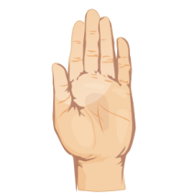
Name
Our Senses Day - Feeling

What could you feel?

I like to feel
because

