KS1/ 2 Home Learning
Arts and Crafts- Superhero Craft cards
This week we will be completing activities around ‘Our Home Heroes’. This could be mums, dads, grandparents, sisters or anyone else who is looking after us right now. They are working so hard to keep you happy and safe.
Here is an activity to create a special Superhero card to thank our home heroes. Create your cards and write a special note inside for your chosen hero
Things you will need  - Coloured card (Alternatively use plain paper and felts / paint to colour)  - Pencil  - Scissors  - Glue (optional)  - Decorations for Superheroes e.g. coloured card, glitter, felt tips, paint.  Follow this link for a video tutorial if needed;  https://www.thebestideasforkids.com/super-hero-craft/ | 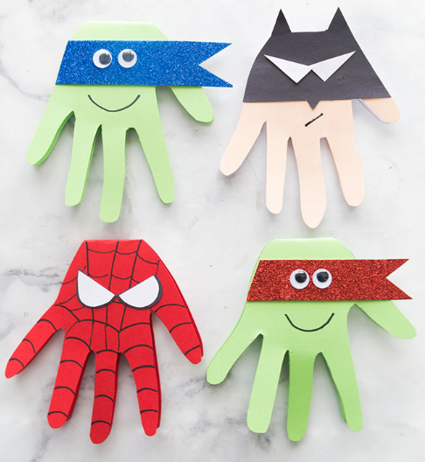
Activity
This activity is to practice drawing, cutting and fine motor skills. Please encourage the pupils to collect their own equipment where possible.

1. First fold your card / paper in half.
2. Trace your handprint with the wrist portion over your folded section.
3. Cut out your handprint ensuring the folded ‘wrist’ section stays intact.
4. Once you have your handprint cut out, use your chosen method to decorate the card. (E.G coloured card, felt tips, paint)
5. Create some eyes for your Superhero and add your smile.
6. Now write your message inside your card!

