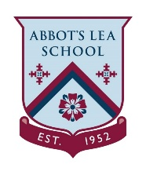

Top 20 interview questions

Practice these interview questions at home with someone
You can watch this clip for some ideas. https://www.bbc.co.uk/bitesize/articles/zfjf92p
Tell me about yourself
- What do you know about the organisation?
- Why do you want to work for us?
- What can you bring to the company?
- What are your weaknesses?
- What are your strengths?
- Why is there a gap in your work history?
- What challenges are you looking for in a position?
- What would an excellent performance look like in this role?
- Tell me an achievement you are proud of
- Why should we hire you?
- What can you do for us that other candidates can’t?
- What would you do in the first month in the job?
- What kind of environment do you like best?
- What’s your dream job?
- What motivates you?
- If you were an animal what would you be?
- Describe your character in under 30 words
- What are your salary expectations?
- Do you have any questions for us?
You can think about:
- What the employer wants to know
- How to answer
- How not to answer
You can write any comments in here if you wish

