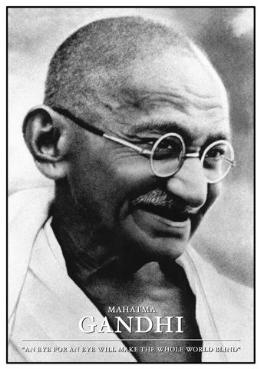**Real Life Heroes**

This is Mahatma Gandhi. He is from I______.

He is known as a hero because he wanted e_______ r______ for people in his c________.

He believed that people should be able to practice any r_________ they want and shouldn’t have to be k_______ for it.

He also did not believe in v________ because he felt that it didn’t solve anything.

He felt that the only way to get people to listen to him is through going on a h________________.

**Word Bank**

**Hunger strike, country, religion, rights, killed, India, violence, Mahatma Gandhi, equal**

**Word Bank**

**Mahatma Gandhi, unfair, bus, white, speech, equal rights, treated, front, play, world, black.**

This is M_____________________. He wanted e_________________ for b_____ people.

He thought it was u_________ the way that they got t__________.

They had to sit at the back of the b___ whilst white people would have to sit at the f_____ of the bus.

W_____ children were not allowed to p_____ with children who were black.

He made a famous s_______ that people listened to all over the w___________.

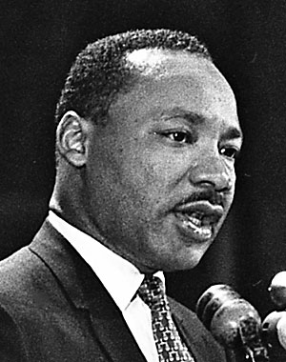

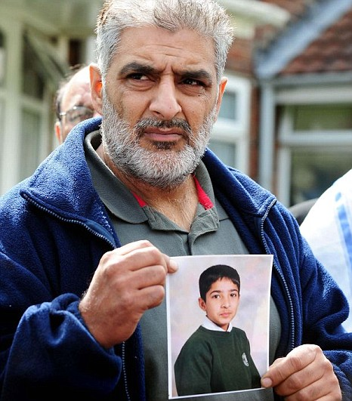

This is T___________. He is from E_________.

His son was run over and k_________ during the r______ in summer 2011.

Lots of people were a_______ about the m__________ and wanted r__________.

Tariq Jahan wanted p________ and came on T__ to tell people to calm down and not h_________ each other.

Lots of people l_________ to him and so he saved the UK from getting into a big f_________.

**Word Bank**

**Listened, TV, peace, harm, angry, murder, revenge, Tariq Jahan, England, killed, riots, fight.**