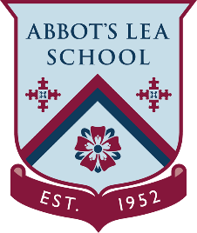
YouTube and other helpful links
The WOW Show
YouTube Channel:
The WOW Show is a 30-minute fast-moving interactive magazine show aimed at giving young people fresh perspectives on the world of work. The Show will turn the spotlight on major employment sectors in a new and exciting way - telling the stories of people who are making a real difference in a range of careers.
https://www.youtube.com/channel/UCXDSgY0E_aACHXcSqX14YNg/featured
Some videos you should watch:
Employability skills – have you got them?
https://www.youtube.com/watch?v=tKKPUYfOkvw
Careers Cast Ep 1
https://www.youtube.com/watch?v=Pe8BjFLhlNk
Careers Cast Ep 2
https://www.youtube.com/watch?v=8xaPSr51d1Q

Website:
“The WOW Show is a live online channel creating real-life encounters with the world of work to inspire young people about their futures.
We are proud to have been named Careers Provider of the Year by the Careers and Enterprise Company and the Gatsby Foundation at the annual Careers Excellence Awards.”
https://www.thewowshow.org/

