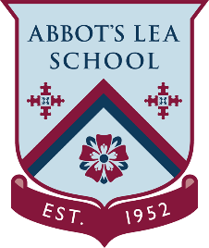
YouTube and other helpful links
BBC Bitesize
BBC Bitesize:
Bitesize is the BBC's free online study support resource for school-age pupils in the United Kingdom. It is designed to aid pupils in both schoolwork and, for older pupils, exams.
Use BBC Bitesize to help with your homework, revision and learning. Find free videos, step-by-step guides, activities and quizzes by level and subject.
“We are adding three new lessons every weekday for each year. Pick yours and get started.”
https://www.bbc.co.uk/bitesize

