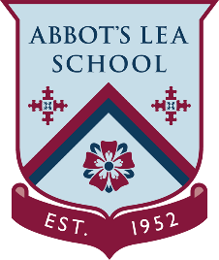
YouTube and other helpful links
Career Connect

“Career Connect is a charity who are passionate about providing high quality independent careers advice, bridging the gap to learning and employment and better life chances for young people and adults.
We provide a wide range of career management services, some funded by Local Authorities and schools and colleges in your area.”

YouTube Channel:
“Here at Career Connect we pride ourselves on listening to people and acting on what they say, so we are always really interested in you!”
https://www.youtube.com/user/connexionslive
Website:
https://www.careerconnect.org.uk
“Young People: Career Connect provides careers information, advice and guidance to young people. We work in a range of schools and colleges, and in many different geographical areas.
In this section, you will find a range of information to support you with your career planning. We are also available for advice face to face and online.
Our services will provide you with independent, impartial and inspirational advice and support.”
https://www.careerconnect.org.uk/Young-People-i2.html

