YouTube and other helpful links
Chester Zoo – Games and Virtual Zoo
What animal are you?
Take a fun Quiz to find out what animal you are! It only takes a couple of minutes, and you can do it as many times as you want.
https://www.chesterzoo.org/play/games/what-animal-are-you/
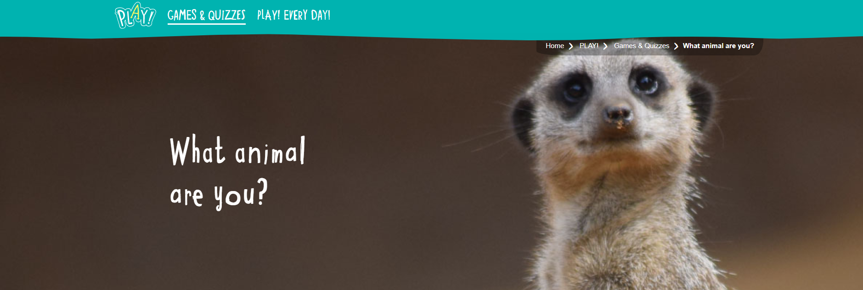
Virtual Zoo Days
Experience the magical sights and sounds of Chester Zoo from your living room!
It looks like lockdown is going to go on a little longer for us and that can mean only one thing… we are once again bringing the zoo to you!
https://www.youtube.com/c/chesterzoo/live
YouTube Channel:
https://www.youtube.com/c/chesterzoo
Website:
https://www.chesterzoo.org/

