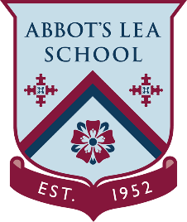
YouTube and other helpful links
College YouTube Channels

Hugh Baird College:
“Hugh Baird College is a further education College situated in Bootle, Merseyside, England. It is one of the largest providers of education and training in the area, delivering over 300 courses to more than 5.000 students.
The college offers courses from Entry Level to Level 3, Apprenticeships and University level courses, Foundation Degrees and Degrees.
The opportunities are here. The expertise is here. The support is here. The inspiration is here. Wherever you want your story to take you, it starts at Hugh Baird College.”
https://www.youtube.com/user/HughBairdCollege
Greenbank College:
“Greenbank College delivers study programmes to young people and courses for adults across various vocational areas.
On this channel we will be sharing videos that will give you an idea of what it is like at Greenbank College including what goes on in the various learning departments, special events as well as content produced by our very own Community Reporters.”
https://www.youtube.com/user/greenbankcoll
The City of Liverpool College:
“Explore over five specialist campuses, each dedicated to helping you discover endless possibilities. Whether you are looking to get back into education, want to explore apprenticeships or wanting to learn about your options after school - get in touch today!”
https://www.youtube.com/user/COLCollege
Knowsley Community College:
“KNOW how to dream big with Knowsley Community College. Our brand new £32 million Main Campus is now open!
Real careers start with real experiences. Start your journey with us and apply today at http://www.knowsleycollege.ac.uk”
https://www.youtube.com/user/KnowsleyCollege

