**YouTube and other helpful links**  
Greenbank College Virtual Open Event



|  |
| --- |
| [https://mcusercontent.com/2fd7a046da72434e863b9d5b5/images/f7bfd06e-d839-4170-b5f0-a6480fb0b4c0.jpg](https://www.youtube.com/c/GreenbankCollege/)[https://mcusercontent.com/2fd7a046da72434e863b9d5b5/images/c8410f45-c250-42fe-a903-04acb5f6d05a.jpg](https://www.facebook.com/greenbankcollege/) |

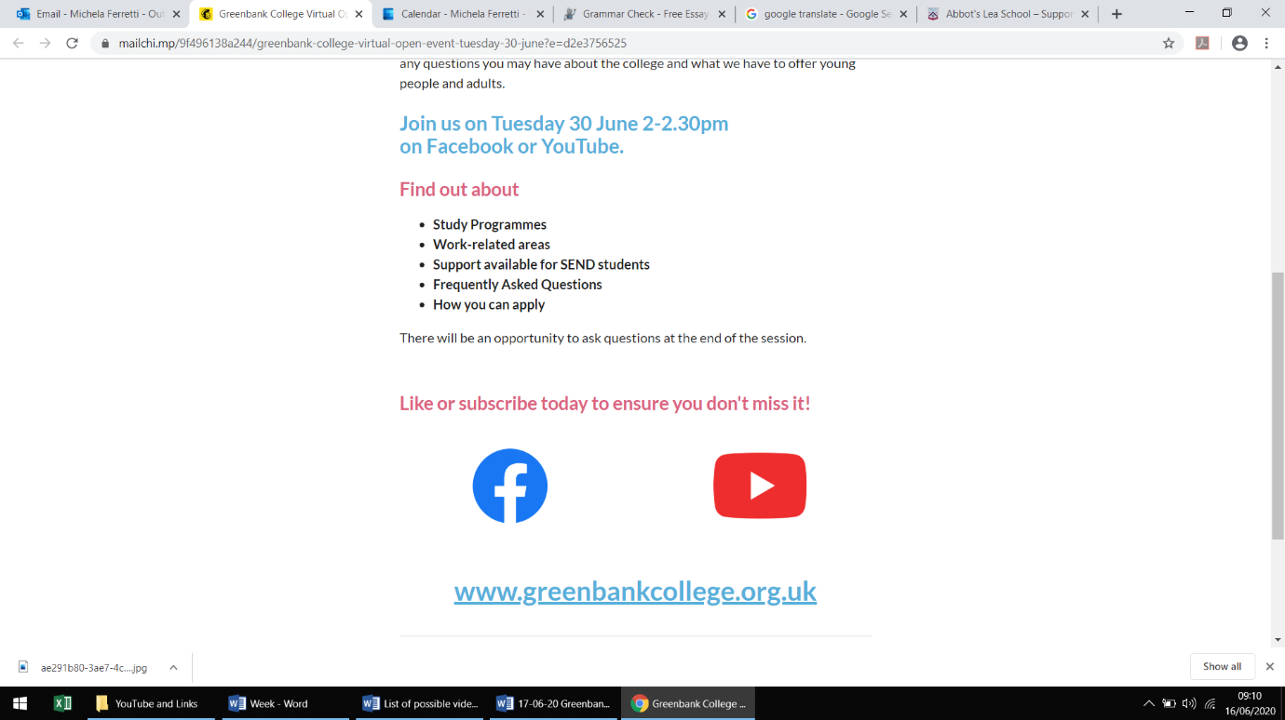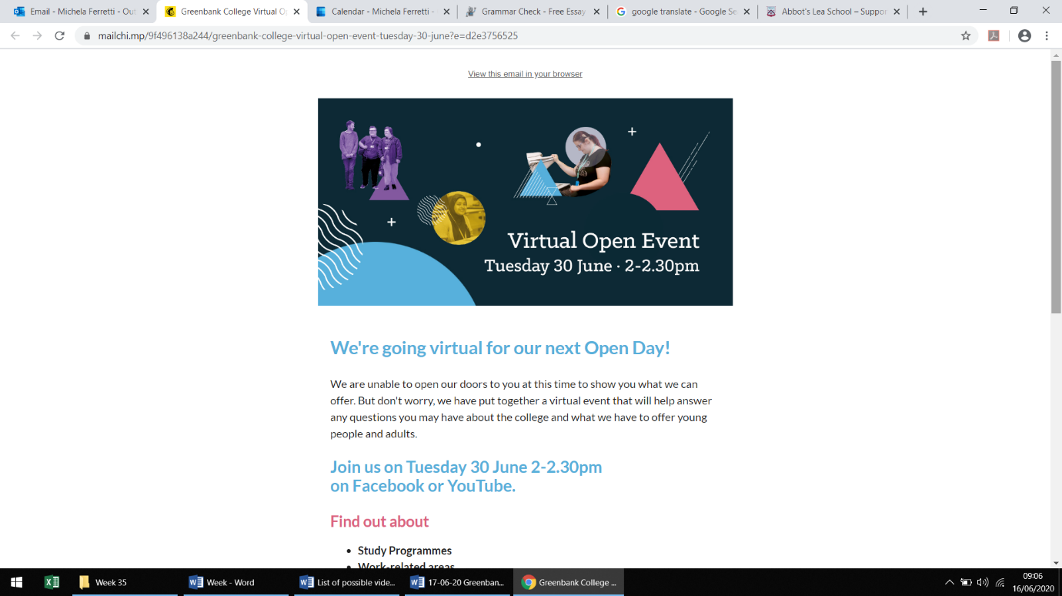  
  
  
  
  
  
  
  
  
  
  
  
  
  
  
  
  
  
  
  
  
  
  
  
  
  
  
  
  
  
  
  
  
  
  
  
  
  
  
  
  
www.greenbankcollege.org.uk