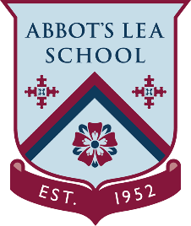
YouTube and other helpful links
NASA – What did Hubble see on your birthday?
What did Hubble see on your birthday?
Hubble explores the universe 24 hours a day, 7 days a week. That means it has observed some fascinating cosmic wonder every day of the year, including on your birthday.
What did Hubble look at on your birthday? Enter the month and date below to find out!
Then share the results with your friends on social media using #Hubble30.”
https://www.nasa.gov/content/goddard/what-did-hubble-see-on-your-birthday
Hubble Space Telescope:
The Hubble Space Telescope is the first major optical telescope to be placed in space, the ultimate mountaintop. Above the distortion of the atmosphere, far far above rain clouds and light pollution, Hubble has an unobstructed view of the universe. Scientists have used Hubble to observe the most distant stars and galaxies as well as the planets in our solar system.
From far to near, from the earliest moments in the universe to current sandstorms on the surface of Mars... Hubble's launching in 1990 marks the most significant advance in astronomy since Galileo's telescope. Our view of the universe and our place within it has never been the same.
Orbiting approximately 340 miles above the surface of Earth, Hubble was the first telescope designed to be visited in space by astronauts to perform repairs, replace parts and update its technology with new instruments. With each of five servicing missions, Hubble's power has increased, making it one of the most enduring and successful space missions ever undertaken.
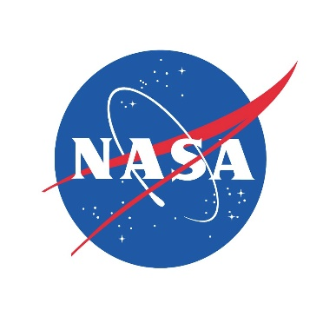
YouTube Channel:
https://www.youtube.com/user/NASAtelevision
View Hubble Videos on YouTube:
https://www.youtube.com/playlist?list=PLiuUQ9asub3Ta8mqP5LNiOhOygRzue8kN

