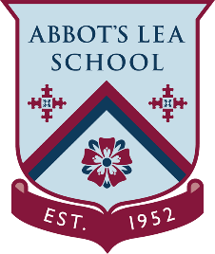
YouTube and other helpful links
Science Experiments!

Do you like Science? Here you will find 3 YouTube Channels with great Science experiments:
Science Max:
Have you ever done a science experiment and wondered “What would this be like if it were HUGE?”. Science Max is a series that turbocharges all the science experiments you have done at home:
https://www.youtube.com/channel/UCbprhISv-0ReKPPyhf7-Dtw
Science Channel:
Learn about outer space, leading scientific exploration, new technology, earth science basics, and more!
https://www.youtube.com/channel/UCvJiYiBUbw4tmpRSZT2r1Hw
SciShow:
SciShow explores the unexpected. Seven days a week, Hank Green, Michael Aranda, and Olivia Gordon delve into the scientific subjects that defy our expectations and make us even more curious!
https://www.youtube.com/user/scishow

