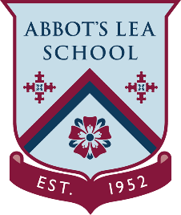
YouTube and other helpful links
University Virtual Tours and YouTube Channels
Here is a list of virtual tours and videos from universities and colleges, so you can see what it's like on campus and what facilities are available:
https://www.ucas.com/undergraduate/what-and-where-study/open-days-and-events/virtual-tours
Liverpool John Moores University:
“Our mission is to create and sustain a vibrant community for learning and knowledge where staff and students work together in an active and supportive partnership; providing opportunities to enrich our students, partners and wider society through education, training, research, scholarship and knowledge transfer.”
https://www.youtube.com/watch?v=YlR34cSAVH0
The University of Liverpool:
“Choose the University of Liverpool a prestigious Russell Group institution and enjoy an amazing, life-changing university experience, in a truly exceptional city with a global reputation for sport, music, architecture and culture.”
https://www.liverpool.ac.uk/virtual-open-day/

University YouTube Channels:
Liverpool John Moores University:
https://www.youtube.com/user/LJMUTV
The University of Liverpool:
https://www.youtube.com/user/UofLTube
Liverpool Hope University:
https://www.youtube.com/user/liverpoolhopeuni1
Liverpool Institute for Performing Arts:
https://www.youtube.com/user/LIPALiverpool

